Bryan D’Amico

[bdamico@syr.edu](mailto:bdamico@syr.edu)

Final Project

Analysis of Magic: The Gathering Cards

MNB, SVM, DT, LDA, VADER

September 17, 2023

# The Magic is all in the Cards

## **Introduction**

Richard Garfield (Fig. 1) loved playing games from a very young age. When he was a teenager in the late 1970s, he learned about this new game Dungeons and Dragons, but couldn’t play it because no stores sold it where he lived. Garfield was determined, however, and set out to start creating his own game. His version of D&D ended up taking place on a game board that looked like it was from the game Clue and involved fighting monsters in different rooms. His passion for creating and inventing only grew and he continued to make games as fun personal projects until early 1991, when he was earning his PhD in Combinatorial Mathematics. It was at this time that Garfield was introduced to Peter Adkison, who was working as an analyst at Boeing. After work hours, however, Adkison was beginning to run a gaming company, which would become known as Wizards of the Coast, out of his basement. When Adkison learned of Garfield’s talent for making games, he asked him to create something portable that people could play with one another at conventions. Garfield accepted his request, and when taking a hike with his family suddenly realized how he could turn a game concept he previously thought of, named Five Magics, into the game Adkison wanted.

**Figure 1) MtG Creator Richard Garfield**



*Source: https://venturebeat.com/games/magic-the-gathering-creator-richard-garfield-starts-game-studio-popularium/*

The actual gameplay of Five Magics had constantly changed in Garfield’s mind, but it was always centered around five different colors that represented different types of energy. Red aggression drew its power from the mountains, white orderliness came from the plains, green growths emerged from forests, black ambition seeped out from the swamps, and blue rumination was inspired from islands. Garfield’s newfound inspiration was to turn this into a card game where the players took the form of wizards who would battle one another by casting spells and summoning creatures. Adkison loved the idea and work on making it a reality started right away.

The very first concept of what became known as Magic: The Gathering, or MtG, looked very different from how it does today. Their “alpha” version of the game consisted of only one hundred and twenty cards that would be randomly split between two players. During each round of play, each player would bet a card from their pile, then use their other cards to duel one another. The winner of the duel took the two cards they bet as a reward and play continued until someone was out of cards.

The “beta” version saw the gameplay change to the basic structure that MtG uses today. Players are still wizards, but are now known as planeswalkers. The goal of the game is to eliminate the opposing player’s life points, which usually start at 20, by dealing damage with spells or summoned creatures. Those actions use a resource known as mana which players are able to channel by playing a land card. The locations featured on the land cards are the same ones that Garfield envisioned with his original Five Magics concept. The cards from this version of the game were simple and silly, often contained random pop culture references (Fig. 2).

**Figure 2) Four of the MtG concept cards**

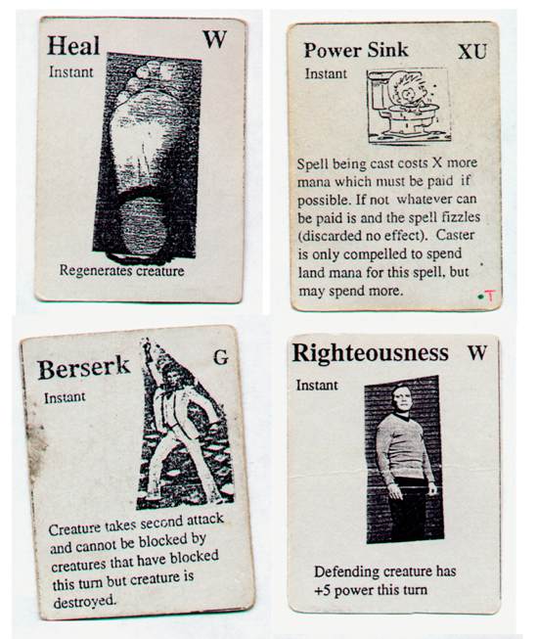

*Source: https://magic.wizards.com/en/news/making-magic/creation-magic-gathering-2013-03-12*

One more revision, “gamma”, saw the game fully morph into MtG as it is known today. This version rebalanced the mana costs of playing cards and added significantly more cards into the mix. Their satisfaction with this version of the game led to the initial print and release of the game in 1993. This initial print included 295 unique cards, and 2.6 million card copies in total were printed. MtG was immediately a huge success and by 1997, over two billion cards had been sold. Players bought cards through booster packs, which were sealed packages of cards which were assembled at random. Cards were also printed at different volumes with the intention of making more powerful cards rarer to find. This created the common feeling of continually wanting to open “just one more pack” among players striving to find certain cards.

The fun of playing the game, opening packs, trading cards, comparing collections, competing in tournaments, and meeting other fans of the game has kept MtG extremely popular for three decades. The game now boasts an estimated 30 million players worldwide, and with all that success comes a lot of pressure on the game designers. From the beginning, Garfield had a very clear concept of the game with distinct identities given to each of his five colors. He also understood the importance of the words printed on the cards. Since the cards can often change the rules of the game being played, they must be very clear. This lesson was reinforced early on with the Starbust card (Fig. 3), when one playtester thought he won his current match, when in reality all he did was skip the other player’s next turn.

**Figure 3) Showing the Necessity of Clear Wording**

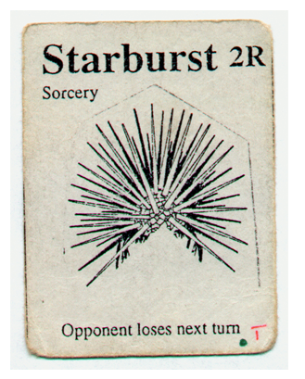

*Source: https://magic.wizards.com/en/news/making-magic/creation-magic-gathering-2013-03-12*

After 30 years of releasing cards, coming up with even more to release is no easy task. It would be impossible even for Garfield himself to know all the cards that have already been printed to make sure they are not printing a card that does the exact same thing as another. This means the design team has to constantly check through thousands of cards when coming up with new ideas to ensure the new card is different enough from the others to capture the interest of players. Another important aspect to consider is known as “power creep”. Power creep happens when in an attempt to make new cards that are really exciting for players, those new cards are so much stronger than older cards that there is no longer any reason to play those old cards. The most important thing designers must consider however, is how their card ideas conform to Garfield’s five colors. Garfield emphasized the importance of each color having their own strengths and weaknesses that could only be balanced by players using multiple colors to accomplish all the things they might want to do. Each color is unique conceptually as well (Fig. 4) dealing with different emotions and themes.

**Figure 4) The Five Colors of Magic: The Gathering**

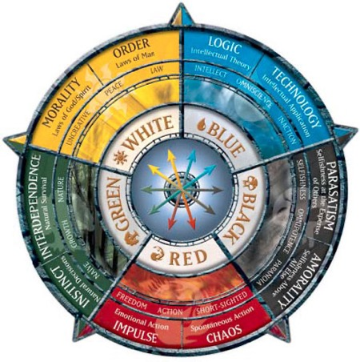

*Source:* [*https://mtg.fandom.com/wiki/Color*](https://mtg.fandom.com/wiki/Color) *(posted by Gwiz665)*

Creating new sets of cards is almost certainly an overwhelming prospect, especially for newly hired game designers. But what if the 30 year history of cards could be used to help the designers instead of just functioning as a constant roadblock to work around? Leveraging the text of MtG cards could produce a game development tool that helps ensure that the text of cards in the development phase adhere to the principles of the color they have been written for. Such a tool could have many beneficial uses including providing an automated round of quality control on newly written cards and serving as a guide that checks the card texts written by new designers to see if they have gotten the color of the card “right”. This could allow game designers to be even more creative with their designs because they can be more confident that their cards will fit into the current structures of the game. Not only would this make the developers’ jobs easier, but it would make playing MtG even more exciting for many years to come.

## **Analysis**

The main goal of this analysis is to develop a classification model that uses the text of the card to predict which color the card should be given. The classification models will be developed using both unigram (single word) and bigram (pairs of consecutive words) features. The development of a classification model could serve as a helpful tool in the game development process to check the designers’ work and make sure that past card themes also agree with how upcoming cards are being written. Then, a topic modeling analysis will be applied to the flavor text on the cards. The flavor text is used to describe the character or scene shown in the card’s art and articulate how it connects to the MtG universe’s overarching lore. This can be used to inform the designers of the types of characters, settings, and actions to focus on when making cards of each color. Lastly, a sentiment analysis will be applied to the flavor text on the cards as well. This will be used to calculate how positive or negative the flavor text should be for each color of card.

### Data Preparation

The data for this analysis was gathered from the internet using the application programming interface, API, from scryfall.com (Fig. 5). This API allows the user to query the Scryfall database, which contains information on every MtG card, at least those printed in English for now. The site is updated constantly to include new cards and more cards printed in other languages. The Scryfall API does not require a key to use and the site only asks users to adhere to reasonable rate limits.

**Figure 5) Scryfall Website**

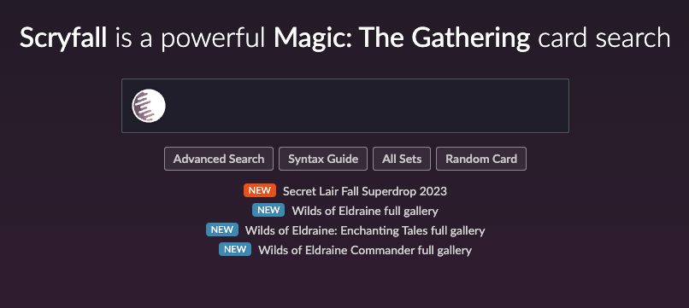

*Source: scryfall.com*

Each page of the database contains the complete information on a given card. Figure 6 shows the Scryfall database entry for the card “Aethergeode Miner”. This database entry contains an image of the card, the name of the card, the mana cost, the card type, the card text that describes what the card does when played, the flavor text that gives background information on the subject of the card as it relates to the MtG universe, the power and toughness of the card, illustration credits, the game formats it is allowed in, and the price of the card as it is found on card reselling sites.

**Figure 6) Scryfall Database Entry for “Aethergeode Miner”**

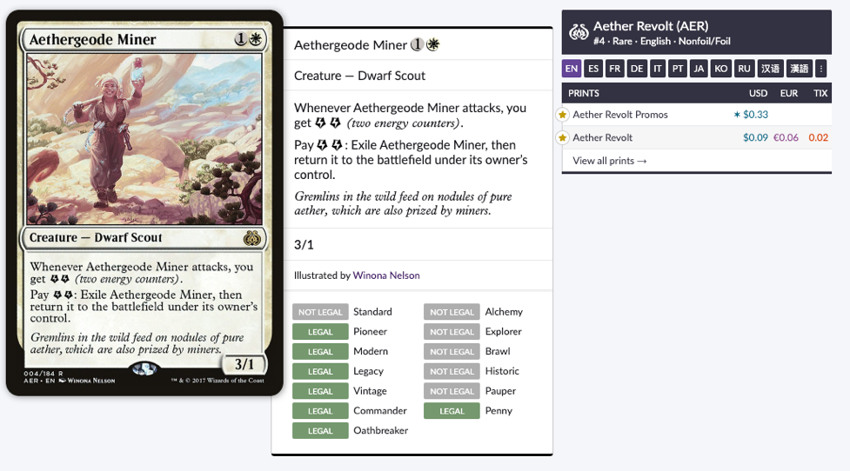

*Source: https://scryfall.com/card/aer/4/aethergeode-miner*

Calls are made to one of the API’s endpoints in Python to gather information and store it in the JSON format. When making an API call and receiving a result, all the same pieces of information on the cards contained in the query as the one shown on the database page are returned. An example of the information returned on a card in JSON format can be seen in Figure 7. JSON format is similar to a Python dictionary where information is saved as a series of nested key value pairs.

**Figure 7) Example of Partial JSON Result of Scryfall API call**

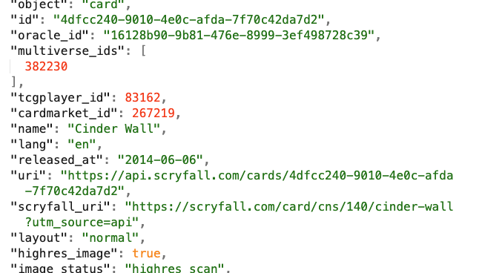

*Source: scryfall.com*

Before gathering the data, a local csv file was prepared to hold the desired information on each card. A new file is opened in Python using the open() function with the “w” parameter so the new file is written. The first line of the csv file will function as the column headings of the data. These columns are the card name, the text, the flavor text, the color, the cost, the type, and the rarity. This first row containing the column labels are written to the csv file (Fig. 8) then the connection to the file is closed.

**Figure 8) Preparing the CSV file with the Column Headers Row**

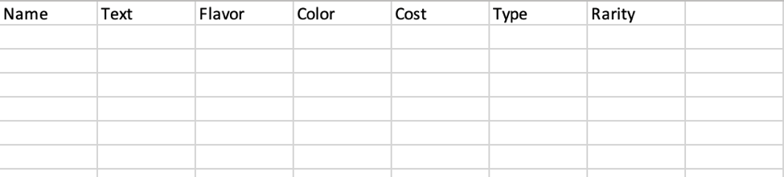

Now that the csv file is prepared, article information was gathered by calling the “cards/search” endpoint. Due to Scryfall’s rate limits, the cards were gathered in separate calls according to their color. The endpoint was queried to only return unique cards of a single color that were not lands and were written in English. Land cards were excluded because these generally do not contain text or perform an action when played. It is important to note that multi-color cards exist in MtG, but these were excluded from the analysis to focus only on cards of a single color. The API returns JSON data organized into pages, where each page holds the data on only a certain number of cards. For this reason, the API calls were first done in a web browser to see how many pages of cards were available for each card color. Once the page range was found, that range was used with a loop variable in a for loop to build the entire JSON data for each color one page result at a time. Each page of data is saved as an item in a list. At the end of each run of the loop, a manual delay of two seconds was put in place to further safeguard against exceeding the rate limits. This process was repeated five times, once for each color of MtG card. The data on each card color was saved separately and accessed one at a time to compile the data into csv format.

The information is gathered in JSON format, so the particular keys in the JSON where the desired pieces of information are stored must be accessed when saving it to the csv file. To accomplish this, a for loop is used to iterate over the list containing each page of data. Within this for loop, the connection to the csv file is reopened using the “a” parameter. This allows new information to be appended to the file. A nested for loop is used to loop over all the cards in the current page of the JSON data. First, for each card, the name is taken from the name subkey within the data key. If the card has a name, the name is converted to a string and the .replace() function is used to remove any commas from the string. If commas are present anywhere in the data, it will cause issues when sending the data into the csv file since the comma is being used as the delimiter. The name string is tokenized by the presence of a space and joined back together while using regular expressions to remove any new line or return characters. If the card does not have a name, the value is set to “NA”. Missing values needed to be manually set to “NA” because if the card does not have a piece of information then both the key and value for that information is missing in the JSON data. Not setting it to “NA” causes a column of data to be “skipped” and the next piece of information then fills in the wrong spot in the csv which throws off all the following data. Next, the card text is taken from the value of the “oracle_text” key. When saving the card text, it is first converted to a string. Then regular expressions are used to process the text by replacing any punctuation with a space, condensing multiple consecutive spaces to a single space, replacing any quotation symbols with a space, replacing any non-letter characters with a space, and then removing any commas. Once again, if the card does not have a value for “oracle_text”, the value is set to “NA”. Next, the flavor text is taken from value of the “flavor_text” key. All the same processing steps are applied to the flavor text and if the flavor text does not exist, the value is set to “NA”. The color of the card is taken from the value of the “colors” key and if the color does not exist then the value is set to “NA”. The cost of the card is taken from the “mana_cost” key and if the card does not have a cost then the value is set to “NA”. The card type is taken from the value of the “type_line” key. The same text processing steps are applied as were for the card and flavor text, and if the card does not have a type then the value is set to “NA”. Lastly, the rarity of the card is taken from the value of the “rarity” key and if the card does not have a rarity then the value is set to “NA”. At the end of each run of the nested for loop, all the information is combined into a single string in the same order as the column names and separated by commas and then written as the next line in the csv file. By separating each piece of information with a comma, they will be successfully filed under the correct columns. The main for loop is run as many times as there are items in the list of pages of JSON data, and once it has finished the connection to the csv file is closed.

This entire process is run five times, once for each list of pages of JSON data for each color. Figure 9 shows a portion of the resulting csv file.

**Figure 9) Preview of the CSV File**

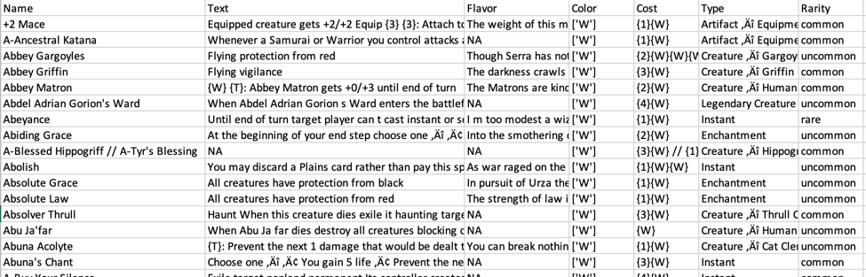

At this point the cards underwent a selection process to determine those that would be used in the analysis. To accomplish this, the csv file was read into Python as a data frame using the read_csv() function from the pandas package. A total of 19,250 cards were obtained from the Scryfall API, so there was enough data to simply eliminate any cards that contained an “NA” value. If any column for any card had a value of “NA”, that card’s entire row was removed from the data frame. The resulting data frame (Fig. 10) contained 12,044 cards. This is still plenty of data for the analysis and ensures that all cards can be used in any the forthcoming analyses without issues.

**Figure 10) Preview of Data Frame with “NA” Values Removed**

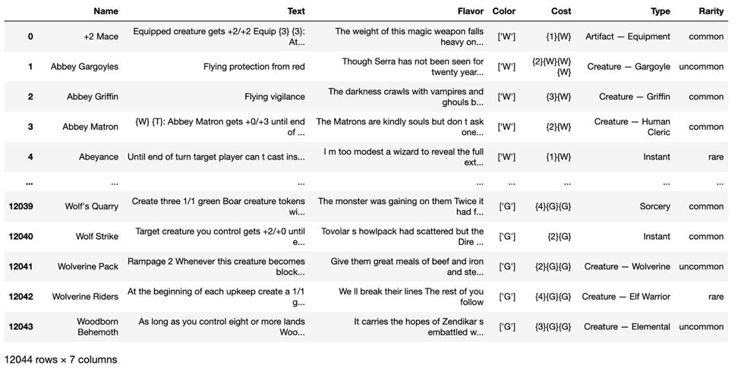

The next step was to perform some very light cleaning to make the data easier to work with. As seen above, the colors are currently represented by a letter inside quotations inside brackets. Also, the color blue is represented by the letter U, which is unintuitive. For these reasons, the color values were replaced with the name of the actual color ([‘W’] changed to White as shown in Figure 11). This change will make the results of the analyses more interpretable for the reader. Once the cleaning step was completed, the results were saved to a new csv file using the to_csv() function.

**Figure 11) Preview of Data Frame with Cleaned Color Names**

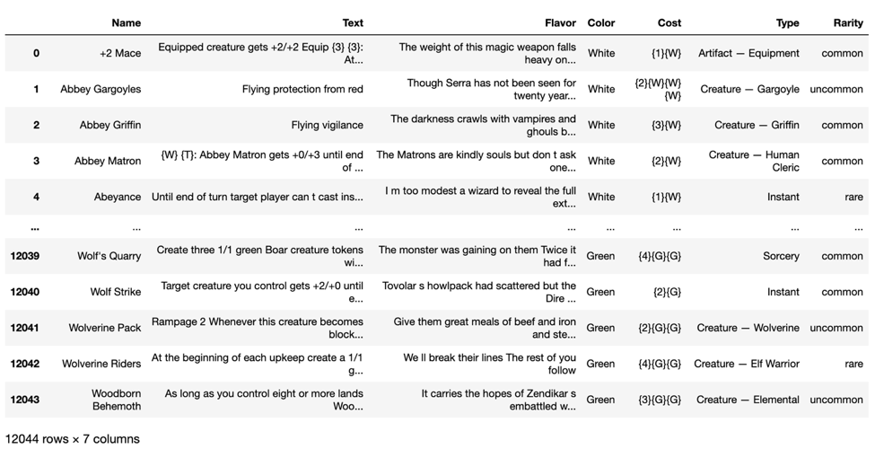

Saving the data as a csv served as a checkpoint. This copy of the data could be brought into any Python program allowing the different types of analyses and models to be run separately with their own unique data preparation steps applied.

### Data Exploration

When re-importing the data from the csv file, a second index column named “Unnamed: 0” appeared (Fig. 12), so this column was promptly dropped from the data frame. Also, since cards were removed from the data while filtering out any “NA” values, the number of cards of each color were visualized using a bar chart (Fig. 13) to ensure an even distribution. It is particularly important to provide a set of data that is balanced according to the target variable to classification models so they can be trained and tested properly. Even after the filtering step, the distribution of cards is very well balanced, with each color having just under 2,500 cards in the data.

**Figure 12) Extra Index Column in Data Frame**

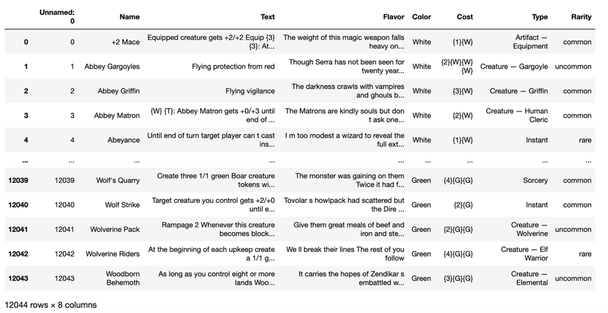

**Figure 13) Distribution of Card Colors**

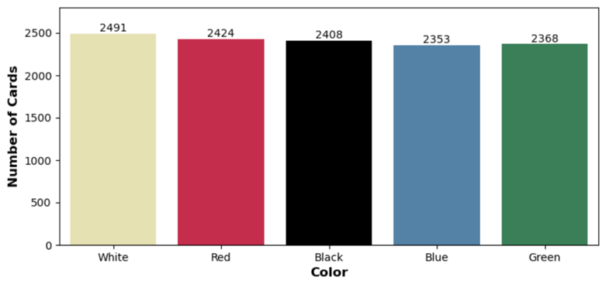

#### Visualizing the Card Texts

To explore the data and understand the words that are commonly used in the cards, twelve word clouds were created. Two word clouds represent all the cards, two represent the white cards, two represent the red cards, two represent the blue cards, two represent the black cards, and two represent the green cards. Within each set of two word clouds, one cloud was made only to contain individual words, while another was made so it can include very commonly seen multi-word phrases. The WordCloud() function from the wordcloud package was used to create each of the word clouds. The maximum font size was set to 100, the maximum number of words was set to 80, the background color was set to white, the minimum word length was set to 3, and the collocations parameter was set to either False or True for each set of two word clouds. The width and height of the word cloud were also manually set to 800x400 to make the word cloud easy to read. The minimum word length was used to avoid any one or two digit numbers in the cards from showing up, while focusing only on words of more substantive length. The collocations parameter identifies whether the word cloud will only display the most common individual words or also include multi-word phrases.

Before creating the word clouds, the texts of the relevant cards for each cloud were saved as a list. This was done by saving the entire “Text” column from the data frame as a list, or by first filtering the data frame by the desired color, then saving all the card texts from that filtered data frame as a list. Since the WordCloud() function accepts a single string as its input, a user defined function was created that joins each separate string in the lists of cards into one string, separating each with a space. The user defined function was applied to the lists containing all the cards and then each separate color.

The first two word clouds, show in Figures 14 and 15, represent the entire set of MtG cards. Those who play MtG will instantly recognize the words in these word clouds. Both word clouds prominently feature very commonly used words within MtG games such as “creature”, “artifact”, “control”, “draw card”, “damage”, “target”, “battlefield”, “graveyard”, and “end turn”. All these refer to either what certain cards represent within the game universe or refer to gameplay mechanics. Many of the smaller words in the word cloud represent actions a card can take or abilities that a card has such as “flying”, “block”, “trample”, “exile”, “enchantment”, and “counter target”. Both word clouds are extremely representative of the entire population of MtG cards and the majority words within would likely be encountered by a new player within a single round of playing the game.

**Figure 14) Word Cloud of All MtG Cards (Collocations = False)**

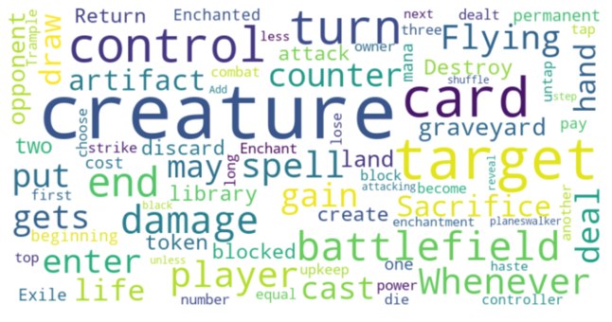

**Figure 15) Word Cloud of All MtG Cards (Collocations = True)**

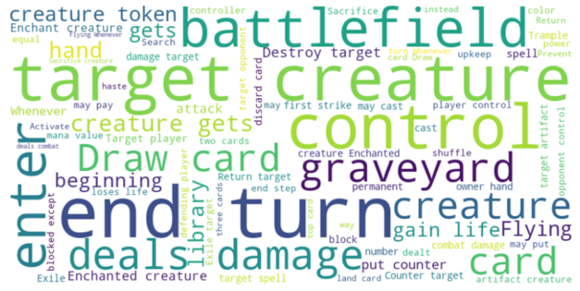

The next two word clouds, shown in Figures 16 and 17, are made from the text on all the white cards. These two word clouds certainly look similar to the previous ones for all the MtG cards. There are a few words that stand out more prominently, meaning that they may be more representative of just the white cards, such as “vigilance”, “spirit”, “strike”, and “lifelink”. These may be highly informative word features during the modeling phase of the analysis. If these words only exist, or exist more prominently, in the collection of white cards then the model should be able to correctly identify the cards containing those words as being white. One important aspect of the word cloud is that the word “white” is featured with a medium size font. This means that “white” cards will often reference their own color in the card text. Since having this word as one of the inputs to the model would be the same as telling it the answer to the classification problem, “white” will need to be filtered out before the vectorization steps.

**Figure 16) Word Cloud of White Cards (Collocations = False)**

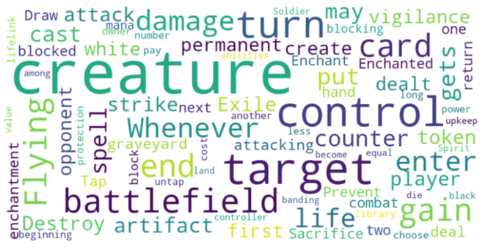

**Figure 17) Word Cloud of White Cards (Collocations = True)**

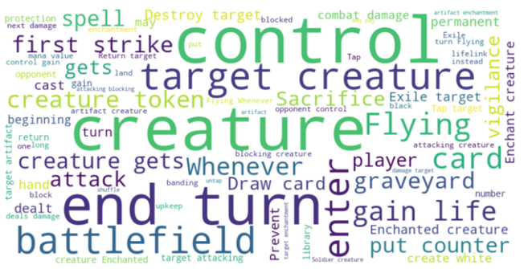

The next two word clouds, shown in Figures 18 and 19, are made from the text on all the red cards. Once again, the general make-up of the word clouds is similar to those created from the entire set of cards. There are certain words and phrases that are more prominent for the red cards, however. Words such as “haste”, “goblin”, “instant”, and “destroy target” either show up only in these word clouds or have a larger font size than in previous word clouds. Also of note is the fact that “deals damage” is now shown with the largest font by far. This makes sense considering that red cards are supposed to be the most aggressive in the game. The word “red” also shows up in the word clouds giving further justification for filtering out the names of the colors before building any classification models.

**Figure 18) Word Cloud of Red Cards (Collocations = False)**

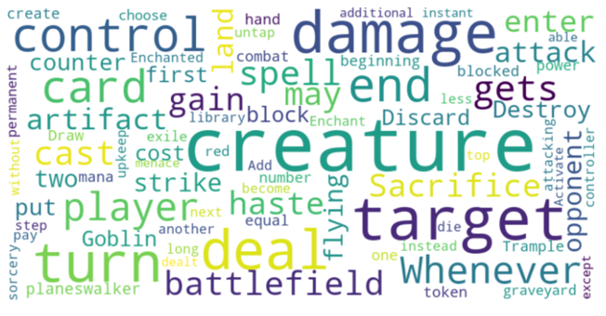

**Figure 19) Word Cloud of Red Cards (Collocations = True)**

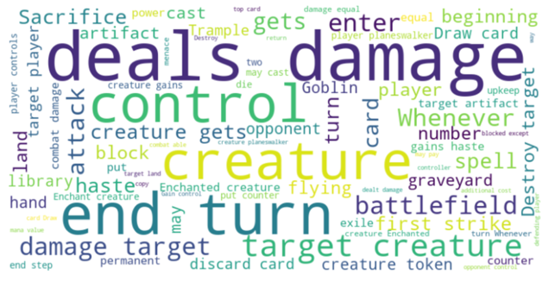

The next two word clouds, shown in Figures 20 and 21, are made from the text on the blue cards. The overall word clouds are similar to the previous ones, but there are again certain words and phrases that stand out more prominently. The word “flying” is among the words with the largest font sizes. This make sense since the creatures represented by blue cards are supposed to originate on the islands and there are many types of birds that live by the ocean. The phrase “draw card” has just as large of font as “flying”. This indicates that the blue cards may allow the player to draw additional cards more often than the cards of the other colors. Other more prominently featured words and phrases are “spell”, “owner”, “return”, and “counter target”. These may be the most important features that the classification models identify as being representative of the blue cards.

**Figure 20) Word Cloud of Blue Cards (Collocations = False)**

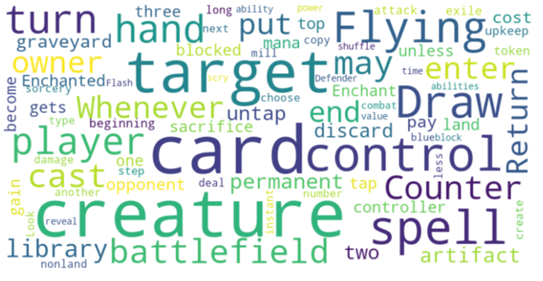

**Figure 21) Word Cloud of Blue Cards (Collocations = True)**

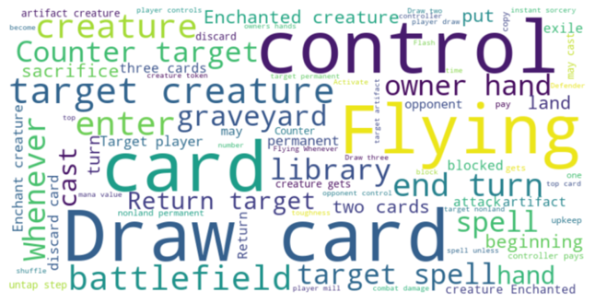

The next two word clouds, shown in Figures 22 and 23, are made from the text on the black cards. As with the other word clouds of an individual color, many of the most common words are the same. These word clouds distinctly showcase more horror themed words such as “zombie”, “vampire”, “deathtouch”, and “exile”. Phrases such as “lose(s) life” are more prominently featured as well and continue to be representative of the overall theme of the black cards. There are not as many distinct words and phrases for this color as compared to the other colors, so this may be a color that the model has some difficulty identifying accurately.

**Figure 22) Word Cloud of Black Cards (Collocations = False)**

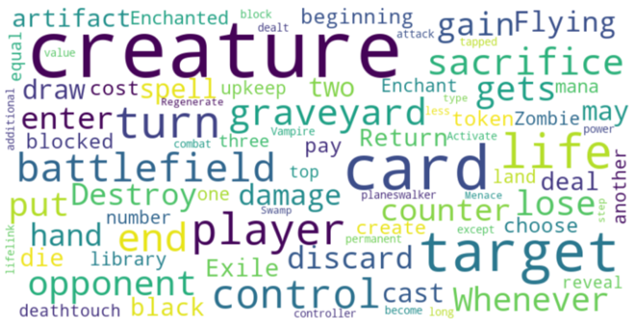

**Figure 23) Word Cloud of Black Cards (Collocations = True)**

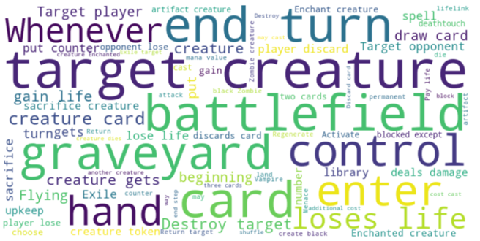

The final two word clouds, shown in Figures 24 and 25, are made from the text on the green cards. As with all the other word clouds, “creature”, “battlefield”, “control”, “target” and other such words and phrases are prominently seen. More specific to the green cards, however, are “trample”, “mana”, “reach”, and “land card”. Green cards feature beasts found in jungles or forests so the word “trample” seems to occur appropriately often. Also, words such as “flying” and “strike” are found less within the green cards than they are in other colors. These differences may be what the classification models focus on when attempting to identify the green cards.

**Figure 24) Word Cloud of Green Cards (Collocations = False)**

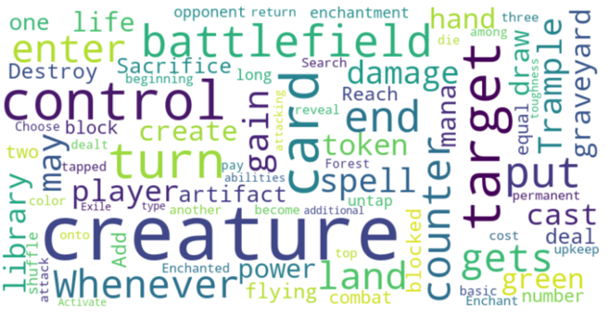

**Figure 25) Word Cloud of Green Cards (Collocations = True)**

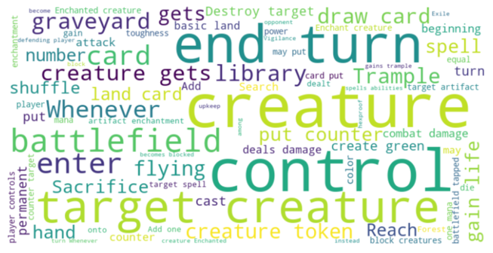

The word clouds show that there are definitely similarities among the different colors of MtG cards. This makes sense because if certain colors could never perform the more common actions found in the game, then those colors would be perceived as weaker leading to them not being played. One-fifth or more of the cards in the game just not being played would significantly decrease the variety of decks and lead to more stagnant game experience for everyone. The word clouds do reveal that the colors have particular focuses though, which give each color a unique identity and allow for different types of decks to excel at taking certain actions.

#### Visualizing the Flavor Texts

The following word clouds were created using the flavor texts of the MtG cards. One word cloud was created from the flavor texts of all the cards, one was made from the flavor texts of the white cards, one was made from the flavor texts of the red cards, one was made from the flavor texts of the blue cards, one was made from the flavor texts of the black cards, and one was made from the flavor texts of the green cards. All the same cleaning and processing steps were applied to the flavor texts as were applied to the card texts. This time the WordCloud() function was given a value of 50 for the max_font_size and max_words parameters. All other parameters were kept the same as in the previous word clouds. The flavor texts were also converted to single text strings using the same process used with the card texts as well.

The first word cloud, shown in Figure 26, represents the flavor texts of the entire set of MtG cards. This word cloud reveals that the flavor texts contain themes of violence and power with words like “death”, “power”, “war”, “fire”, “blood”, and “dead”. There is a reference to a particular type of creature with “goblin” and a particular location with “forest”. The flavor texts also contain some religious themes as shown by words like “soul” and “god”.

**Figure 26) Word Cloud of Flavor Texts for All Cards**

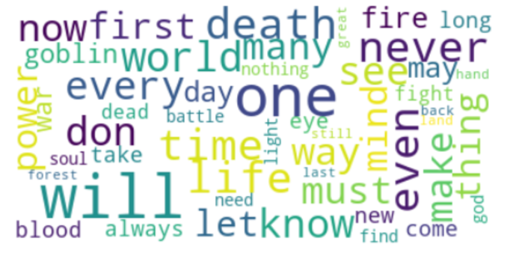

The word cloud shown in Figure 27 represents the flavor texts of the white cards. The white cards contain more of the religious themes with words like “god”, “angel”, “hope”, “light”, and “soul”. These words combined with words like “soldier”, “blade”, “battle”, and “sword” inspire images of crusaders. There are also references to the “sun” and “sky” which also feel appropriate for the white color of cards.

**Figure 27) Word Cloud of Flavor Texts for White Cards**

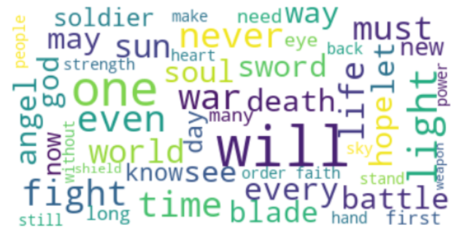

The word cloud shown in Figure 28 represents the flavor texts of the red cards. This word cloud certainly channels the energy of mountains and fire that the red cards are supposed to be thematically based on. Words like “mountain”, “fire”, “flame”, “dragon”, and “rock” are all very representative of the typical fantasy portrayals of mountainous regions. There is also a secondary theme of violence and battle represented by words such as “blood”, “death”, “goblin”, “rage”, and “burn”.

**Figure 28) Word Cloud of Flavor Texts for Red Cards**

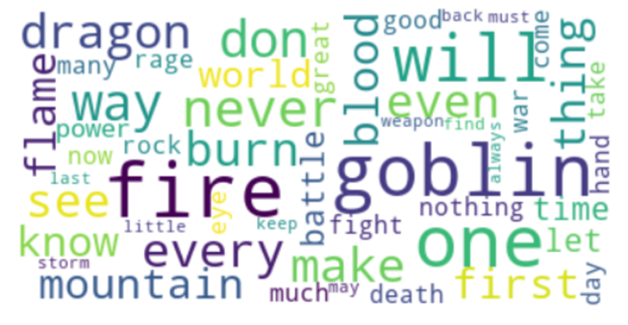

The word cloud shown in Figure 29 represents the flavor texts of the blue cards. The words in this word cloud feature some words that describe things that are literally blue such as “water”, “sea”, and “sky”. There is also a magical theme found in the word cloud from words such as “mage”, “magic”, “wizard”. Taken together, the flavor texts definitely represent the original image of the blue cards: magical creatures contemplating their knowledge on lonely islands.

**Figure 29) Word Cloud of Flavor Texts for Blue Cards**

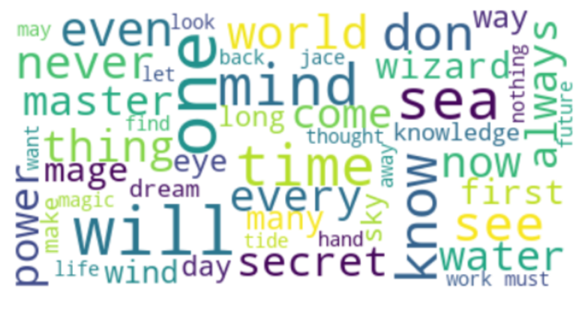

The word cloud shown in Figure 30 represents the flavor texts of the black cards. This word cloud contains many words dealing with the macabre and could easily be mistaken for representing a horror novel. Words like “shadow”, “fear”, “bone”, “night”, “blood”, and “dark” call stories of vampires, zombies, and other evil creatures to mind. The black cards are supposed to deal with the powers of life and death and that is clear from the word cloud with the appearance of words like “death”, “living”, “life”, “soul”, “flesh”, and “blood”.

**Figure 30) Word Cloud of Flavor Texts for Black Cards**

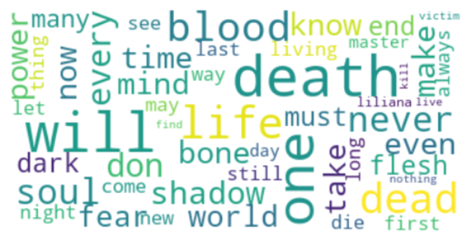

The final word cloud, shown in Figure 31, represents the flavor texts of the green cards. This word cloud is very representative of the MtG color green as well as where green is seen in real life with words like “forest”, “nature”, “tree”, and “land”. The words “beast”, “hunter”, “prey”, “grow”, and “wild” all evoke images of a lifestyle that is both within and dependent on nature for survival. There are also some fantasy elements that are traditional related to woodland environments such as “elves” and “druid”.

**Figure 31) Word Cloud of Flavor Texts for Green Cards**

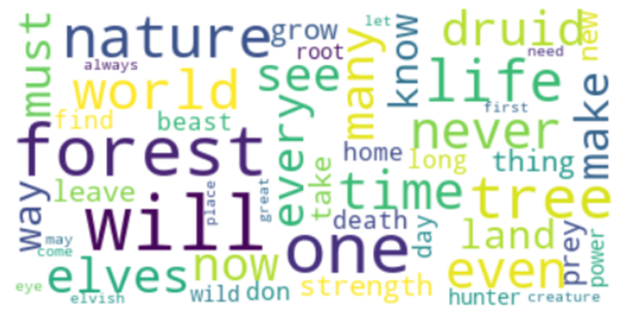

### Magic: The Gathering Specific Stop Words

Since the main goal of the analysis to build a model that can predict the color of a card based on its text, retaining words that are very common in the text of all the colors of cards as features in the model would be counterproductive to that goal. For that reason, the results of the word clouds combined with knowledge of the basic game functions that are prevalent in all the card colors were used to construct a list of MtG specific stop words. This list will be used as an additional layer of stop words that is appended on to the default list of English stop words during the analysis. The following words, shown in Figure 32, comprise the list of MtG stop words.

**Figure 32) List of Magic: The Gathering Specific Stop Words**

['target', 'creature', 'control', 'battlefield', 'turn', 'end', 'opponent', 'player', 'card', 'artifact', 'cast', 'counter', 'spell']

### Additional Cleaning to Prepare for Vectorization

Using the data frame imported into Python from the cleaned csv file as the starting point, an additional layer of cleaning steps were applied to the text on each card before beginning the analysis.

Two lists were initialized, one that would hold the data from the Text column of the data frame and one that would hold the data from the Color column of the data frame. A for loop was used with both each text and color entry used as the loop variables where the loop iterates over each one in a zip object created through the pairing of each text and color value. Each text value is appended to one of the initialized lists and each color value to the other.

A new list was initialized that would hold the results of the upcoming cleaning process. Then, a for loop was used on the list containing the card text to iterate over all the text entries. For each string of text, a series of regular expressions and text cleaning functions were applied. Each string was processed by replacing any punctuation with a space, condensing multiple consecutive spaces to a single space, replacing any quotation symbols with a space, and replacing any non-letter characters with a space. The strings were tokenized according to any spaces created then rejoined into a single string. Additionally, any new line or carriage return characters were removed. Lastly, any words that are two characters or less were removed. At the end of each run of the for loop, the document is appended to the newly initialized list.

The word clouds revealed that the card colors were often named in the card texts. For example, green cards sometimes refer to a power that creates “green tokens”. This type of information cannot be passed as input to the classification models, or they will be trained using the answers to the predictions. Each card text in the cleaned text list that was just created is tokenized using a space as the separator and then a new list is initialized that will hold all the words. A nested for loop is then used to iterate over all the words, set them all to lowercase, then test them against a conditional statement. The conditional statement compares each word token to a list containing the five MtG colors. If the word currently being checked does not match any of the five colors, then it is appended to the new list. The new list of words is then joined together to recreate the card text, without the words matching the colors. This process is repeated for the text from every card and a new list of cleaned card texts without any mention of the colors is produced.

### CountVectorizer and TfidfVectorizer

The two vectorization functions used in this analysis are CountVectorizer and TfidfVectorizer from the sklearn.feature_extraction.text package. CountVectorizer works by returning a count of how often each word appears in each separate card. TfidfVectorizer, or term frequency-inverse document frequency vectorizer, works by returning a normalized and weighted frequency. The numeric value is calculated by multiplying the count of how often a word appears in a card by the inverse document frequency of the word, or one divided by the number of cards the word appears in. This method boosts the scores of rare words, or words that are present in fewer of the cards, and penalizes the scores of common words, or words that are present in more of the cards. The reasoning behind this is that very common words that appear in almost all the cards should not be rated as informative features when passing this information to a classification model.

The CountVectorizer and TfidfVectorizer functions work by reading in text data, splitting it into separate tokens, setting all the tokens to lowercase, then counting the number of occurrences of each token in each document. The functions are first instantiated by defining the type of input it will receive and tuning any of its parameters. The function is then used on the input data by calling the .fit_transform() method on the instance of vectorizer. The output of this step is a document term matrix saved a sparse matrix object. A sparse matrix is a matrix where most of the entries are 0. This type of output makes sense for this application since there will be many times when a word occurs in just one of the input documents and none of the others. To properly work with the output of the function it will be converted to a pandas DataFrame. The .get_feature_names_out() method is called on the instance of the vectorizer to get a list of the word features from the cards. This list will serve as the column names of the data frame. The data frame is then created using the DataFrame() function from the pandas package. This function is given an array version of the sparse matrix as its input by calling the .toarray() method on the sparse matrix and the columns parameter is passed the list of feature names. Each row of the data frame represents one of the input documents and each column represents a word in the cards. Each column is comprised of numeric data where the number in each cell corresponds with a numeric value representing the frequency of the occurrences of that word in that card.

### Instantiating the Vectorizers

For the classification analysis using unigram word feature data, three sets of six instances of the vectorizers were created. Within each set, two instances of CountVectorizer, two instances of binary CountVectorizer, and two instances of TfidfVectorizer were made. All the parameters within each set were kept the same, except for the ones that were purposely varied. For each of the two instances of each type of vectorizer, one was set to have a max_features value of 250, while the other was set to have a max_features value of 350. The max_features parameter is used to determines the top words ordered by term frequency across all the reviews and saves those as the word features. Using a limited number of word features avoids overfitting the model by not letting the entire vocabulary serve as variables in the upcoming classification models.

The first set of six vectorizers all used the built-in English stop words list provided by the vectorizers by setting the stop_words parameter to “english”. The second set of six vectorizers used a custom stop words list that appended the MtG specific stop words to the list of English stop words. This custom list was created by importing the text.ENGLISH_STOP_WORDS from sklearn.feature_extraction and saving that list of stop words as a variable. The text.ENGLISH_STOP_WORDS list is a frozen set, however, meaning that it cannot be edited. To get around this limitation the frozen set was saved within another list and then a for loop was used to iterate over the items to save them in a new list. This one could be edited, and the words that were identified as MtG stop words from the word cloud analysis were each appended into that list. The third set of six vectorizers used a value of None for the stop_words parameter so that no stop words were removed.

All the vectorizers had their input type set to “content” since the vectorizers are receiving the lists of cleaned strings of card text that were imported into Python through the csv file. Additionally, a user defined tokenization function that will lemmatize the text was also passed to all instances of CountVectorizer and TfidfVectorizer. Lemmatization is the process of stemming words, by removing the suffixes from the inflected forms of words then altering the word stem to ensure it is a complete word. The user defined function takes a string as its input then tokenizes the string using the sub function from the re package. This function replaces patterns defined by a regular expression with another pattern. In this case, the regular expression is written to match any character that is not a letter or a hyphen. When a character is matched it is replaced by a space. The insertion of spaces over those characters tokenizes the text. Furthermore, the .lower() and .split() methods are called on this to set all the letters in each token to lowercase and then create a list where each token is an individual element of that list. Each word token in that list is then lemmatized using the WordNetLemmater().lemmatize() function. The list of lemmatized words is returned as the output from the custom lemmatization function. When this is passed as the argument for the tokenizer parameter in the vectorizers, the entire process described above is performed on each card text before the word frequency counts are taken.

For the classification analysis using unigram and bigram data, one instance of CountVectorizer was created. The choice to instantiate CountVectorizer, along with the parameters that were used, was informed by the performance of the models in the unigram analysis. The data that was used in the top performing unigram models was replicated in all aspects except for setting the ngram_range parameter to (1, 2). This means that the word features produced in the vectorization step can be unigrams or bigrams. Otherwise, the input parameter was set to “content”, the stop_words parameter was set to the custom list of English and MtG stop words, the binary parameter set to True, and the max_features parameter set to 350.

For the topic modeling analysis, six instances of CountVectorizer were created: one for the entire set of cards, and then one for each of the separate colors. The input type was set to “content” since the vectorizers are receiving lists of cleaned text. The stop_words parameter was set to “english”. All other parameters were left as their default values. This means that the results of the vectorizers were not limited by the max_features parameter. By returning the major bulk of the vocabulary used as word features, the topic modeling analysis will be able to able to most authentically discover the topics contained within the flavor texts of the cards.

### Vectorization and Data Frame Preparation

The process and results of this stage of the data preparation will be shown separately for the classification models and the topic modeling analysis.

#### Classification Models

The list of all the cleaned card texts was vectorized using both CountVectorizer and TfidfVectorizer with the settings as described in the previous section for the unigram and bigram analyses. This process created a total of nineteen data frames. The first eighteen data frames correspond to the three sets of six vectorizer instances used in the unigram analysis. The final data frame was the one produced with the unigram and bigram word features that would be compared against the top performing unigram models. A preview of the data frame created by the CountVectorizer instance with English stop words removed and the max_features parameter set to 250 for the unigram analysis is shown in Figure 33 and the data frame created by the CountVectorizer instance for the unigram and bigram analysis is shown in Figure 34.

**Figure 33) Preview of Unigram Data Frame (CountVectorizer with max_features = 250)**

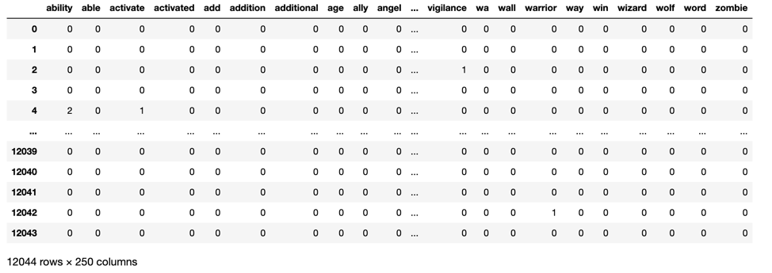

**Figure 34) Preview of Unigram and Bigram Data Frame (Binary CountVectorizer with max_features = 350)**

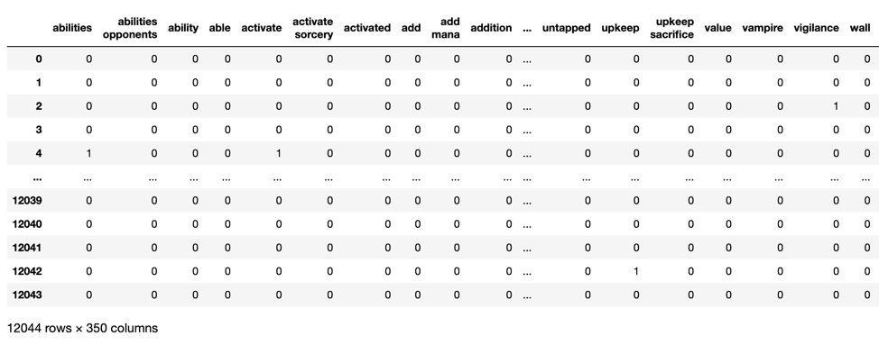

Once each data frame was created, an additional cleaning step was applied to the word features serving as the column names in the data frame. Word features with less than three characters were removed so that the model is trained only on more substantive words with several letters. These shortened words may have arisen due to the lemmatization process. This was accomplished by using a for loop to iterate over every column of the data frame and use a conditional statement to check if the column name was shorter than three characters. If it was, that column was dropped from the data frame. A preview of this cleaned version of the data frames produced by the CountVectorizer instance with English stop words removed and the max_features parameters set to 250 is shown in Figure 35. The filtering process reduced the data frame to 246 features.

**Figure 35) Preview of Filtered Data Frame (CountVectorizer with max_features = 250)**

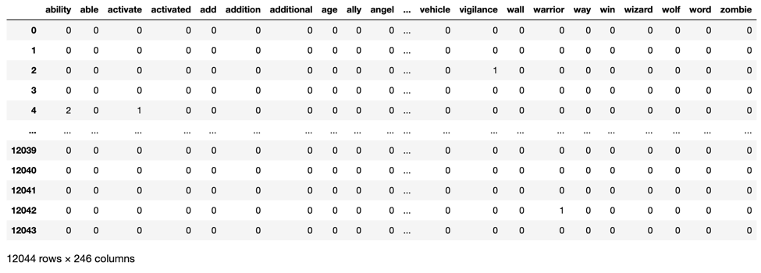

To prepare the data frames for the classification model training and testing process, the color labels were appended as their own columns at the start of each data frame. Figure 36 shows the preview of the data frame created by the CountVectorizer instance with English stop words removed and the max features set equal to 250 after this step was applied.

**Figure 36) Data Frame with Color Label Column (CountVectorizer with max_features = 250)**

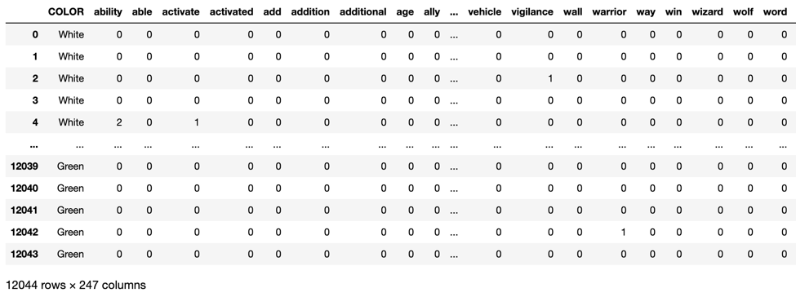

Next, any rows that contained only values of zero were removed from the data frames. These rows provide no information to the model so they should be excluded. The result of this step as it was applied to the data frame created by the CountVectorizer instance with English stop words removed and the max_features parameter set equal to 250 is shown in Figure 37. In this particular case, there was one row of all zero values that was removed.

**Figure 37) Data Frame with All Zero Rows Removed (CountVectorizer with max_features = 250)**

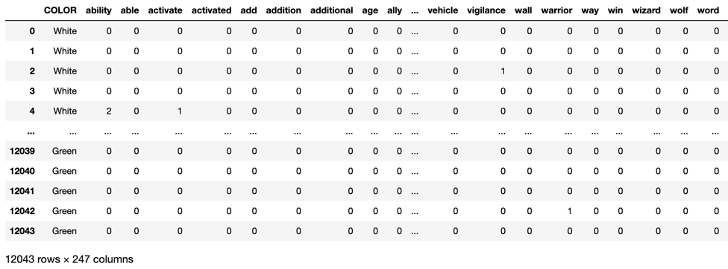

When performing a classification model analysis, it is important to test the model on data that is different from what it was trained on. Failing to do so is the equivalent of a student taking a test with the answer key. Therefore, the train_test_split function was imported from sklearn.model_selection to partition the data. This function takes one set of data and separates it into training and testing data sets. The model will learn from the training data and then its accuracy will be assessed using the testing data. In the function, all the word feature columns were set as the explanatory, or independent, variables, and the color labels were set as the response, or dependent, variable. The data was split such that 80% of the data was included in the training set and 20% of the data was used in the testing set. The random_state parameter was set to 99 so the data is partitioned in the same way every time the code is run ensuring reproducibility of the analysis. Lastly, the stratify parameter was set as the color label column. This tells the function to split the data in such a way that the proportion of card texts with each label in the training data is the same as in the testing data.

#### Topic Modeling

The cleaned lists of flavor texts for all cards and for each color of cards were used as the basis of the topic modeling analysis. Although the topic modeling algorithm uses the sparse matrix, and not the data frame, as its input, those data frames were still created as a nicer version of the data to be shown in this section.

Figures 38 through 43 display a preview of each of those data frames, giving a glimpse into some of the words found in each list of flavor texts, as well as how many distinct word features were returned for partition of the cards. The number of rows in the data frame is equivalent to the number of cards, while the number of columns is equivalent to the number of distinct words.

**Figure 38) Preview of Vectorized Data for LDA (All Cards)**

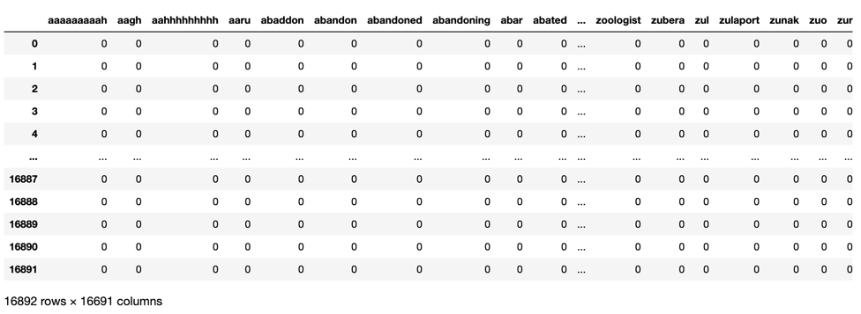

**Figure 39) Preview of Vectorized Data for LDA (White Cards)**

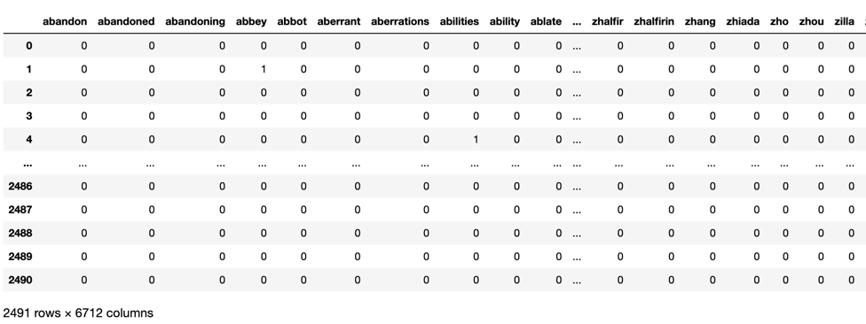

**Figure 40) Preview of Vectorized Data for LDA (Red Cards)**

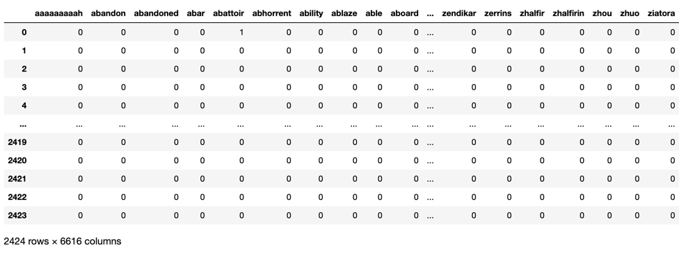

**Figure 41) Preview of Vectorized Data for LDA (Black Cards)**

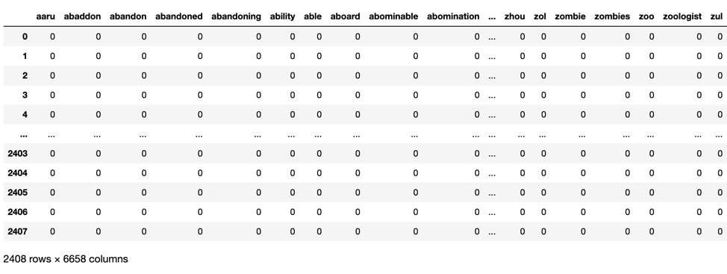

**Figure 42) Preview of Vectorized Data for LDA (Blue Cards)**

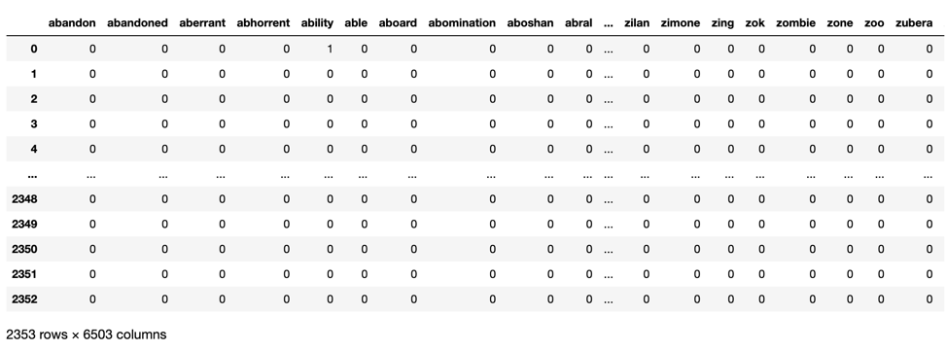

**Figure 43) Preview of Vectorized Data for LDA (Green Cards)**

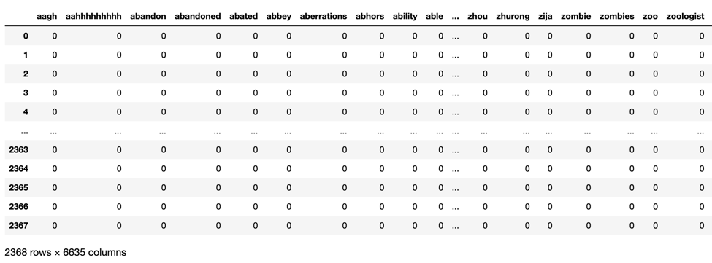

### Multinomial and Bernoulli Naïve Bayes Classification Models

The Naïve Bayes classification model works by calculating probabilities that each card is in each of the target classes based on the input features. The model then makes a final classification prediction for each card based on which probability is greater. These probabilities are calculated by multiplying together all the individual probabilities of each word feature given the target label. When doing this, the model assumes that all the features are independent and make equal contributions to the outcome.

The Multinomial Naïve Bayes, or MultinomialNB, and Bernoulli Naïve Bayes, or BernoulliNB, classification models are used in this analysis. These models are particularly suited for classification using discrete features, with the difference being that MultinomialNB works with word counts such as those created by CountVectorizer or TfidfVectorizer, while BernoulliNB requires Boolean values such as those created when CountVectorizer has the binary parameter set to True. It is important to note that a Naïve Bayes model imposes a Laplace smoothing parameter of 1 by default. This is a constant that is added to the numerator and denominator of the conditional probabilities that are multiplied together to get the final probability of a card being in one target class or the other. This avoids a situation where one probability of zero for one of the features would force the entire probability to equal zero through the multiplication.

In this analysis, the default versions of the MultinomialNB and BernoulliNB classifiers were instanced. The MultinomialNB instances were used with the CountVectorizer and TfidfVectorizer data, while the BernoulliNB instances were used with the CountVectorizer data where the binary parameter had been set equal to True.

To train a Naïve Bayes model, the .fit() method is called and the explanatory and response variables from the training data are passed as the inputs. After the model is trained, the .score() method is called and the explanatory and response variables from the testing data are passed as the inputs. Calling this method returns an accuracy score that reports the percentage of cards that were correctly classified when comparing the results against the actual labels of the test data.

### Support Vector Machines Classification Models

Support Vector Machines, or SVMs, are another type of model that is commonly used in text classification tasks. In this analysis, SVMs with the linear, polynomial, and radial basis function (RBF) kernels were used. The following explanation of how SVMs work is based on the use of the linear kernel. First, one should imagine each review as a data point arranged in space with more similar cards closer to one another and more different cards farther from one another. The goal of the SVM classifier is to fit a linear boundary between the points representing the different categories of the data. Different boundaries are tested by the model and the final one selected is the one that maximizes the margin between the different categories of the data. If the data is not perfectly linearly separable there is a parameter called the slack variable that can be tuned. The default value of this parameter is 1. Increasing its value makes the boundary selection stricter, allowing for no misclassifications, while decreasing its value allows for more classification errors to be accepted.

When the SVM kernel is set to polynomial, the classifier maps the data into a higher-dimensional space (so beyond two dimensions) with the goal of finding a hyperplane that will separate the different colors of cards. When the SVM kernel is set to RBF, the classifier combines several polynomial kernels of varying degrees multiple times to map the data into higher dimensional space with the goal of again finding a hyperplane that will separate the different colors of cards.

SVMs are innately a binary classifier, but in this analysis, have been extended to multi-class classifications. This can be done by employing a pairwise strategy where many classifiers are created so each class can be compared head to head to decide on what class each data example should be. Another strategy is called one versus all, where as many classifiers as categories are created and each data example is tested as being the first category or not, the second category or not, and so on.

SVMs that do not use a linear kernel can be difficult to interpret, but in general this type of model has many advantages. It is tolerant to noisy data, scalable to large data sets, creates a probabilistic prediction result, and has a proven track record of being successful in real world applications. SVMs are also generally more computationally expensive and time consuming to run when compared to Naïve Bayes models. For this reason, the smaller number of word features (250) was used as the data for the SVM models.

In this analysis, the support vector classifier, SVC, provided by the sklearn.svm package was used. Three instances of each of the three kernels were created for the unigram analysis. Each set of three kernels is applied to the data with a different stop words setting. After comparing the results of the analyses, the best combination of kernel and input data was used with the greater number of word features (350) to see if the accuracy would be improved. For the unigram and bigram analysis, that same top performing kernel was used. Each instance of the SVM kernels were created with their default settings for a fair comparison. The SVM classifiers were trained and tested using the .fit() and .score() methods as were used with the Naïve Bayes models.

### Decision Trees

Decision Tree classification models were used also used to classify the cards according to their color. A decision tree is made up of a series of nodes and splits each focusing on different variables that were passed to the model as inputs. Based on the values of each of the variables that the model deems most important in separating the target classes, a diagram of “yes-no” decisions are made that lead to a final prediction. Figure 44 is a very simple example of a decision tree created to solve a popular text mining problem of deciding whether Alexander Hamilton or James Madison wrote a series of controversial anonymous essays contained within the collection of the Federalist Papers. Starting from the first node, the model will choose a variable and a boundary value. Depending on the actual value of the variable compared to the boundary value, each node will branch off in two directions leading to either a terminal node, where a final prediction is made, or a node that features another split based on the boundary value of a variable. By following each branch of the tree from the top to the bottom, one can read each reason why the model made its predictions. For this reason, decision trees are regarded as one of the most interpretable classification models, as long as the complexity of the model is kept in check.

**Figure 44) Simple Decision Tree Example**

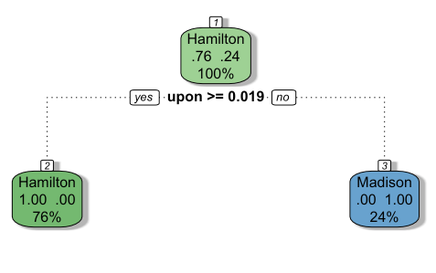

*If an anonymous essay had a value for the “upon” word feature that was greater than or equal to 0.019, this decision tree would assign authorship to Hamilton, while if the value was less than 0.019, it would assign authorship to Madison.*

In this analysis, the DecisionTreeClassifier from the sklearn.tree package was used. Three instances of the classifier were created: one for the data created by CountVectorizer, one for the data created by CountVectorizer with binary = True, and one for the data created by TfidfVectorizer. All the decision tree models were instantiated using the same parameters for consistency across the analyses. The criterion parameter was set to “entropy”, so the splits are made based on the amount of difference between the target classes based on the variable in that node. The splitter parameter is set to “best”, so the decision tree is making the best splits, instead of splitting at random. The max depth parameter is set to a loop variable. A for loop is used to train, test, and display each model for max depths of 8, 10, and 12. The min_samples_split parameter is set to 2, so for a split to occur there must be at least 2 cards in each target class. The random_state value was set to 99 so the same results would occur each time the model is run. This is done to ensure reproducibility of this analysis. All other parameters were left to their default settings.

After instantiating the decision tree classifier, the model is trained using the .fit() method with the explanatory and response variables from the same training data as used with the Naïve Bayes models as inputs. Once the model is trained, the .score() method is called and the explanatory and response variables from the testing data are passed as the inputs. Calling this method returns an accuracy score that reports the percentage of cards that were correctly classified when comparing the results against the actual labels of the test data.

In addition to just seeing the accuracy, the full decision tree can be visualized. This is done using the plot_tree() function from the sklearn.tree package. By passing this function the decision tree classifier, a list of the feature (or variable) names, and a list of the target class names, the decision tree is created. Each node displays the splitting variable and its boundary value, the measure of entropy for that node, and the number of samples that passed through the node. After each node the split is shown, where if the conditional statement with the boundary value is true for the text it moves left in the split, and if the conditional statement with the boundary value is false for the text it moves right in the split.

### Latent Dirichlet Allocation

The topic modeling algorithm used in this analysis is latent Dirichlet allocation, or LDA. LDA is used to discover the main themes that exist within a set of documents and organizes the documents according to those themes. In this sense, a topic is treated as a distribution of the vocabulary of the documents, where each word is described by its probabilistic relevance to each topic.

LDA takes a corpus, or collection of texts, as its input. This corpus must be changed from words into numerical features. This is generally done by using vectorization, as was done in this analysis. The algorithm makes some assumptions about its input. The first is that the text collection is a “bag of words”, so the algorithm does not care about the word order, the actual meaning of the words, or the words’ parts of speech. The second is that the documents have been generated by the number of topics that are requested of the algorithm. This means that, in a sense, LDA works backwards. It assumes that the topics have created the documents, and not that topics will be retrieved from the documents. The third assumption is that each document is a mixture of the topics. This means that a single document will not be called a single topic as each document in the collection should contain multiple topics. The fourth assumption is that each topic is a distribution of word weights. This means that the documents are probability distributions over each of the topics. The final assumption is that for each assignment of a word to a topic that all the previous assignments are correct except for the word that is currently being assigned to a topic.

First, the user defines the number of topics that should be returned by the LDA algorithm. The algorithm then loops through each of the documents and randomly chooses a topic to which to assign each word. After the first step, the algorithm begins to make the assumption that all the topic assignments are correct, except for the current word it’s considering. At this stage the algorithm goes through each word and makes adjustments, one word at a time, to try to improve the topic assignment through the use of two probabilities it calculates for each word. Words will continue to be reassigned until the algorithm decides that the optimal representation has been reached.

In this analysis, the LatentDirichletAllocation function from the sklearn.decomposition package is used. Six LDA instances were created: one for the flavor texts of all the cards, one for the flavor texts of the white cards, one for the flavor texts of the red cards, one for the flavor texts of the blue cards, one for the flavor texts of the black cards, and one for the flavor texts of the green cards. Each instance of the LDA function was instantiated with the max_iter parameter set equal to 100. This means that the algorithm will run through its process until the optimal representation has been reached or until it has completed 100 passes over the data, whichever comes first. The learning_method parameter was set to “online”. This method makes the LDA run much faster compared to the default value of “batch”. The random_state parameter was set to 99 to ensure reproducibility. This is important because the first step of the algorithm is to randomly assign words to topics. Setting a random_state parameter means that the initial random assignment will happen in the same way each time, leading to the same end results. The n_components parameter, which represents the number of topics, was set equal to 10.

After being instantiated, the .fit_transorm() method is called on the LDA instance and the sparse matrix is passed as the input. This actually runs the LDA process on the data. To neatly display the results, a user defined function named display_topics was used. This function takes the LDA model, the feature names (provided from the columns of the data frames shown in the previous section), and the number of words the user wants displayed for each topic as its inputs. The function then loops over each topic in the .components_ method of the LDA model and prints the name of the topic and then the top feature names as sorted by their importance to that topic. This function was called on each run of the LDA model to produce the topics.

### Sentiment Analysis via VADER Sentiment Intensity Analyzer

The Valence Aware Dictionary for Sentiment Reasoning (VADER) sentiment intensity analyzer was chosen as a pre-trained classifier which would be applied to the flavor text data. A pre-trained classifier was chosen because there are no available sentiment labels for this data. VADER provides both scores for the polarity of the sentiment, whether it is positive or negative, and the intensity of that emotion. This tool uses a lexicon that was built by human raters that assigns sentiment scores to words, acronyms, and even emoticons. These scores range from negative 4 to positive 4, where negative 4 is the most negative sentiment and positive 4 is the most positive sentiment. When the sentiment intensity analyzer is given a complete piece of text as an input, it returns an overall score for that text, called the compound score, which ranges from a value of negative 1 to positive 1. If the compound score is greater than or equal to 0.05, the text is classified as positive, and if the compound score is less than or equal to negative 0.05, the text is classified as negative. Otherwise, the text is classified as having a neutral sentiment. The compound scores are generated by taking the sum of the sentiment scores of each word in the text being analyzed that is present in the VADER lexicon and then normalizing that sum. In this analysis, the aggregate compound scores of the colors of cards will be compared and used to determine how positive or negative the flavor text for cards of each color should be.

### Analysis Goals and Parameters

The main goal of the analysis is to choose the best classification model among the Naïve Bayes models, decision trees, and SVMs created. This classification model serves as an initial candidate for the tool that could help the development team create new cards. The secondary goals for the analysis are to use LDA to find the most prevalent topics of the flavor texts of each color of card, and to use VADER sentiment analysis to determine the positivity or negativity of the flavor texts of each color of card.

## **Results**

Each of the following sections focuses on the results from a different part of the analysis. At the end of each section, the results are discussed in comparison to one another along with an explanation of how those results fit into the overall goals of the analysis.

### Most Informative Features from Naïve Bayes Models

As the first step in the Multinomial Naïve Bayes experiments, the ten most informative features for each color of card were generated from the trained Naïve Bayes models.

#### Naïve Bayes Models using English Stop Words Data

The first set of most informative features lists was taken from the Multinomial Naïve Bayes model trained and tested on the CountVectorizer data.

The ten most informative features for each color of MtG card determined by their log probabilities are shown in Figures 45 through 49. When comparing the lists to one another it can be seen that some of the features are repeated fairly often. These are also many of the same words that will be excluded as part of the MtG stop words such as “creature”, “battlefield”, “target”, “card”, “player”, and “turn”. Looking past these words does reveal some differences between the colors that the model has picked up on. For example, “damage” is one of the top features for the red cards, aligning with their aggressive nature. The word “sacrifice” is only found in the list for the black cards, “land” is only present on the list for the green cards, “spell” is only in the list for the blue cards, and “gain” is unique to the list for the white cards. This means that the model has identified features that can differentiate the colors. There may also be more features past the top 10 that further differentiate the classes as well.

**Figure 45) Ten Most Informative Features for the Black Cards**

|  |  |  |  |  |
| --- | --- | --- | --- | --- |
| 1) creature | 2) card | 3) target | 4) life | 5) turn |
| 6) player | 7) control | 8) end | 9) battlefield | 10) sacrifice |

**Figure 46) Ten Most Informative Features for Blue Cards**

|  |  |  |  |  |
| --- | --- | --- | --- | --- |
| 1) card | 2) creature | 3) target | 4) control | 5) spell |
| 6) draw | 7) flying | 8) turn | 9) player | 10) hand |

**Figure 47) Ten Most Informative Features for Green Cards**

|  |  |  |  |  |
| --- | --- | --- | --- | --- |
| 1) creature | 2) control | 3) card | 4) target | 5) turn |
| 6) battlefield | 7) end | 8) counter | 9) land | 10) enters |

**Figure 48) Ten Most Informative Features for Red Cards**

|  |  |  |  |  |
| --- | --- | --- | --- | --- |
| 1) creature | 2) target | 3) damage | 4) deal | 5) turn |
| 6) control | 7) end | 8) card | 9) player | 10) cast |

**Figure 49) Ten Most Informative Features for White Cards**

|  |  |  |  |  |
| --- | --- | --- | --- | --- |
| 1) creature | 2) target | 3) control | 4) turn | 5) battlefield |
| 6) flying | 7) card | 8) end | 9) gain | 10) damage |

The second set of most informative features lists was taken from the Bernoulli Naïve Bayes model trained and tested on the binary CountVectorizer data.

The ten most informative features for each color of MtG card determined by their log probabilities are shown in Figures 50 through 54. These lists look largely similar to the previous lists and contain many of the MtG stop words. The model was again able to determine some differences between the colors, however. This time “graveyard” is only found in the list for the black cards, “draw” and “spell” are only found in the list for the blue cards, “counter” is only found in the list for the green cards, “damage”, “deal”, and “sacrifice” are only found in the list for the red cards, but there are no words unique to the list for the white cards. This model may perform better for the first four colors because there are more words that uniquely identify each color, but the accuracy when classifying the white cards may be worse due to the lack of a unique top word feature.

**Figure 50) Ten Most Informative Features for the Black Cards**

|  |  |  |  |  |
| --- | --- | --- | --- | --- |
| 1) creature | 2) target | 3) card | 4) life | 5) turn |
| 6) end | 7) battlefield | 8) player | 9) control | 10) graveyard |

**Figure 51) Ten Most Informative Features for Blue Cards**

|  |  |  |  |  |
| --- | --- | --- | --- | --- |
| 1) card | 2) target | 3) creature | 4) control | 5) draw |
| 6) spell | 7) flying | 8) turn | 9) hand | 10) battlefield |

**Figure 52) Ten Most Informative Features for Green Cards**

|  |  |  |  |  |
| --- | --- | --- | --- | --- |
| 1) creature | 2) target | 3) control | 4) turn | 5) card |
| 6) battlefield | 7) end | 8) enters | 9) counter | 10) gain |

**Figure 53) Ten Most Informative Features for Red Cards**

|  |  |  |  |  |
| --- | --- | --- | --- | --- |
| 1) creature | 2) target | 3) damage | 4) deal | 5) turn |
| 6) end | 7) control | 8) card | 9) player | 10) sacrifice |

**Figure 54) Ten Most Informative Features for White Cards**

|  |  |  |  |  |
| --- | --- | --- | --- | --- |
| 1) creature | 2) target | 3) control | 4) turn | 5) battlefield |
| 6) gain | 7) end | 8) flying | 9) card | 10) enters |

The third set of most informative features lists was taken from the Multinomial Naïve Bayes model trained and tested on the TfidfVectorizer data.

The ten most informative features for each color of MtG card determined by their log probabilities are shown in Figures 55 through 59. Once again, the lists are similar to the previous ones and contain many of the MtG stop words, but this combination of data and Naïve Bayes model has assigned more value to some different words for the colors. The word “owner” is now among the most informative features for the blue cards. The word “trample” is now in the list of the most informative features for the green cards. Those who play MtG will know that trample is a very “green” ability for a card to have so it is good that the model has picked up on this. Similarly, “haste” is now in the list of most informative features for the red cards which is also a very “red” ability for a card to have. Out of all the models created using the data where the English stop words were removed, this one may perform the best because of those extra couple of informative features that are very representative of their color.

**Figure 55) Ten Most Informative Features for the Black Cards**

|  |  |  |  |  |
| --- | --- | --- | --- | --- |
| 1) creature | 2) card | 3) life | 4) target | 5) turn |
| 6) player | 7) end | 8) sacrifice | 9) graveyard | 10) battlefield |

**Figure 59) Ten Most Informative Features for Blue Cards**

|  |  |  |  |  |
| --- | --- | --- | --- | --- |
| 1) card | 2) draw | 3) target | 4) creature | 5) flying |
| 6) spell | 7) control | 8) hand | 9) owner | 10) player |

**Figure 60) Ten Most Informative Features for Green Cards**

|  |  |  |  |  |
| --- | --- | --- | --- | --- |
| 1) creature | 2) turn | 3) control | 4) target | 5) card |
| 6) end | 7) battlefield | 8) counter | 9) trample | 10) land |

**Figure 61) Ten Most Informative Features for Red Cards**

|  |  |  |  |  |
| --- | --- | --- | --- | --- |
| 1) damage | 2) deal | 3) creature | 4) target | 5) turn |
| 6) end | 7) control | 8) haste | 9) player | 10) card |

**Figure 62) Ten Most Informative Features for White Cards**

|  |  |  |  |  |
| --- | --- | --- | --- | --- |
| 1) creature | 2) target | 3) control | 4) flying | 5) turn |
| 6) gain | 7) end | 8) battlefield | 9) life | 10) enters |

#### Naïve Bayes Models using Additional MtG Stop Words Data

The first set of most informative features lists was taken from the Multinomial Naïve Bayes model trained and tested on the CountVectorizer data.

The ten most informative features for each color of MtG card determined by their log probabilities are shown in Figures 63 through 67. Removing the MtG stop words from the data has resulted in very different lists. The lists for each color are also much more varied than in the previous lists. The list for the black cards now features several words that deal with the theme of death including “graveyard”, “destroy”, and “sacrifice”. The list for the blue cards features some words unique to this list now, such as “permanent” and “untap”. The list for the green cards again includes “trample” and now features words such as “land”, “token”, and “mana”. The list of words for the red cards is very aggressive with words like “damage”, “haste”, “attack”, and “strike”. The list for the white cards also has a unique word feature now with the inclusion of “exile”. Previous sets of lists showed a weakness where there was a not a strong top word feature to indicate that a card was white.

**Figure 63) Ten Most Informative Features for the Black Cards**

|  |  |  |  |  |
| --- | --- | --- | --- | --- |
| 1) life | 2) graveyard | 3) sacrifice | 4) gain | 5) enters |
| 6) discard | 7) destroy | 8) hand | 9) damage | 10) flying |

**Figure 64) Ten Most Informative Features for Blue Cards**

|  |  |  |  |  |
| --- | --- | --- | --- | --- |
| 1) draw | 2) flying | 3) hand | 4) owner | 5) enters |
| 6) return | 7) library | 8) permanent | 9) untap | 10) discard |

**Figure 65) Ten Most Informative Features for Green Cards**

|  |  |  |  |  |
| --- | --- | --- | --- | --- |
| 1) land | 2) enters | 3) gain | 4) trample | 5) damage |
| 6) library | 7) token | 8) hand | 9) create | 10) mana |

**Figure 66) Ten Most Informative Features for Red Cards**

|  |  |  |  |  |
| --- | --- | --- | --- | --- |
| 1) damage | 2) deal | 3) sacrifice | 4) haste | 5) gain |
| 6) enters | 7) attack | 8) land | 9) flying | 10) strike |

**Figure 67) Ten Most Informative Features for White Cards**

|  |  |  |  |  |
| --- | --- | --- | --- | --- |
| 1) flying | 2) gain | 3) damage | 4) enters | 5) life |
| 6) token | 7) strike | 8) exile | 9) attack | 10) destroy |

The second set of most informative features lists was taken from the Bernoulli Naïve Bayes model trained and tested on the binary CountVectorizer data.

The ten most informative features for each color of MtG card determined by their log probabilities are shown in Figures 67 through 71. These lists again show some substantial differences between the top word features for each color. Most of the word features are the same as in the previous lists, but now have different rankings. While each of the top word features for each color is different, the second most informative feature for the blue and white cards is “flying”. This may indicate that creatures with the flying ability is a point of major overlap between these colors within the game design. Discarding cards may be an ability that is more unique to black cards. The words “create” and “token” are both in the list of top features for the green cards. Here, the model has successfully identified a game mechanic of the green cards. Some of their creatures will generate additional token creatures that are used to attack other players or bolster defenses against attacks. The word “exile” again appears in the list for the white cards. This may indicate that this mechanic is a good way to determine if a card should be given the white color.

**Figure 67) Ten Most Informative Features for the Black Cards**

|  |  |  |  |  |
| --- | --- | --- | --- | --- |
| 1) life | 2) sacrifice | 3) graveyard | 4) gain | 5) enters |
| 6) destroy | 7) discard | 8) hand | 9) damage | 10) flying |

**Figure 68) Ten Most Informative Features for Blue Cards**

|  |  |  |  |  |
| --- | --- | --- | --- | --- |
| 1) draw | 2) flying | 3) hand | 4) owner | 5) enters |
| 6) return | 7) library | 8) permanent | 9) graveyard | 10) discard |

**Figure 69) Ten Most Informative Features for Green Cards**

|  |  |  |  |  |
| --- | --- | --- | --- | --- |
| 1) enters | 2) gain | 3) land | 4) trample | 5) damage |
| 6) library | 7) token | 8) hand | 9) draw | 10) create |

**Figure 70) Ten Most Informative Features for Red Cards**

|  |  |  |  |  |
| --- | --- | --- | --- | --- |
| 1) damage | 2) deal | 3) sacrifice | 4) haste | 5) enters |
| 6) gain | 7) attack | 8) land | 9) flying | 10) strike |

**Figure 71) Ten Most Informative Features for White Cards**

|  |  |  |  |  |
| --- | --- | --- | --- | --- |
| 1) gain | 2) flying | 3) enters | 4) damage | 5) life |
| 6) token | 7) attack | 8) exile | 9) create | 10) destroy |

The third set of most informative features lists was taken from the Multinomial Naïve Bayes model trained and tested on the TfidfVectorizer data.

The ten most informative features for each color of MtG card determined by their log probabilities are shown in Figures 72 through 76. While at first glance, these lists are similar to the previous ones, this combination of Naïve Bayes model and vectorized data seems to have done the best job at uncovering key words and mechanics that can separate the cards based on color. Once again words such as “sacrifice” and “graveyard” are found on the list for the black cards. The list for the blue cards contains “hand”, “permanent”, and “untap”. The list for the green cards contains “trample” as the most informative feature and also “land”, “reach”, and “token”. The list for the red cards contains “damage”, “deal”, “haste”, “attack”, “block”, and “strike”. Finally, the list for the white cards contains “enchantment”, “vigilance”, “tap”, and “exile”. The list for the white cards now contains several unique top word features. There are also more words that are unique between all the lists for the different colors. These top features lists give the impression that these models will do well when classifying the test data.

**Figure 72) Ten Most Informative Features for the Black Cards**

|  |  |  |  |  |
| --- | --- | --- | --- | --- |
| 1) life | 2) sacrifice | 3) graveyard | 4) discard | 5) destroy |
| 6) enters | 7) loses | 8) gain | 9) flying | 10) hand |

**Figure 73) Ten Most Informative Features for Blue Cards**

|  |  |  |  |  |
| --- | --- | --- | --- | --- |
| 1) draw | 2) flying | 3) hand | 4) owner | 5) return |
| 6) enters | 7) discard | 8) library | 9) permanent | 10) untap |

**Figure 74) Ten Most Informative Features for Green Cards**

|  |  |  |  |  |
| --- | --- | --- | --- | --- |
| 1) trample | 2) enters | 3) land | 4) gain | 5) add |
| 6) library | 7) blocked | 8) reach | 9) token | 10) draw |

**Figure 75) Ten Most Informative Features for Red Cards**

|  |  |  |  |  |
| --- | --- | --- | --- | --- |
| 1) damage | 2) deal | 3) haste | 4) sacrifice | 5) attack |
| 6) land | 7) gain | 8) strike | 9) enters | 10) block |

**Figure 76) Ten Most Informative Features for White Cards**

|  |  |  |  |  |
| --- | --- | --- | --- | --- |
| 1) flying | 2) gain | 3) enters | 4) life | 5) damage |
| 6) strike | 7) enchantment | 8) vigilance | 9) tap | 10) exile |

#### Naïve Bayes Models using No Stop Words Data

The first set of most informative features lists was taken from the Multinomial Naïve Bayes model trained and tested on the CountVectorizer data.

The ten most informative features for each color of MtG card determined by their log probabilities are shown in Figures 77 through 81. The word lists are all now very similar to one another, and many of them include words such as “you”, “the”, and “this”. It will be very interesting to see how these models perform compared to the previous ones which were more focused on words that describe card abilities and game mechanics. The initial impression provided by these lists are that these models should perform worse, at least based on just the top ten most informative features for each color.

**Figure 77) Ten Most Informative Features for the Black Cards**

|  |  |  |  |  |
| --- | --- | --- | --- | --- |
| 1) creature | 2) you | 3) card | 4) the | 5) target |
| 6) your | 7) life | 8) this | 9) turn | 10) player |

**Figure 78) Ten Most Informative Features for Blue Cards**

|  |  |  |  |  |
| --- | --- | --- | --- | --- |
| 1) card | 2) creature | 3) you | 4) the | 5) target |
| 6) your | 7) control | 8) spell | 9) draw | 10) this |

**Figure 79) Ten Most Informative Features for Green Cards**

|  |  |  |  |  |
| --- | --- | --- | --- | --- |
| 1) creature | 2) you | 3) the | 4) your | 5) control |
| 6) card | 7) target | 8) turn | 9) this | 10) battlefield |

**Figure 80) Ten Most Informative Features for Red Cards**

|  |  |  |  |  |
| --- | --- | --- | --- | --- |
| 1) creature | 2) you | 3) target | 4) damage | 5) the |
| 6) deal | 7) turn | 8) this | 9) control | 10) end |

**Figure 81) Ten Most Informative Features for White Cards**

|  |  |  |  |  |
| --- | --- | --- | --- | --- |
| 1) creature | 2) you | 3) the | 4) target | 5) control |
| 6) turn | 7) this | 8) your | 9) battlefield | 10) flying |

The next set of most informative features lists was taken from the Bernoulli Naïve Bayes model trained and tested on the binary CountVectorizer data.

The ten most informative features for each color of MtG card determined by their log probabilities are shown in Figures 82 through 86. Once again, the lists are very similar to one another and very few MtG words are in the lists. There are only a few such as “creature”, “life”, “battlefield”, and “control”. These are the same words that were determined to be too common among all the colors to be informative, however. These lists also give the impression that these models will not perform as well as the previous ones.

**Figure 82) Ten Most Informative Features for the Black Cards**

|  |  |  |  |  |
| --- | --- | --- | --- | --- |
| 1) creature | 2) target | 3) you | 4) card | 5) the |
| 6) this | 7) life | 8) your | 9) turn | 10) and |

**Figure 83) Ten Most Informative Features for Blue Cards**

|  |  |  |  |  |
| --- | --- | --- | --- | --- |
| 1) card | 2) target | 3) creature | 4) you | 5) the |
| 6) control | 7) draw | 8) this | 9) spell | 10) your |

**Figure 84) Ten Most Informative Features for Green Cards**

|  |  |  |  |  |
| --- | --- | --- | --- | --- |
| 1) creature | 2) you | 3) the | 4) target | 5) control |
| 6) turn | 7) your | 8) card | 9) this | 10) battlefield |

**Figure 85) Ten Most Informative Features for Red Cards**

|  |  |  |  |  |
| --- | --- | --- | --- | --- |
| 1) creature | 2) target | 3) damage | 4) deal | 5) you |
| 6) turn | 7) the | 8) this | 9) end | 10) control |

**Figure 86) Ten Most Informative Features for White Cards**

|  |  |  |  |  |
| --- | --- | --- | --- | --- |
| 1) creature | 2) you | 3) target | 4) the | 5) control |
| 6) turn | 7) this | 8) until | 9) gain | 10) end |

The final set of most informative features lists was taken from the Multinomial Naïve Bayes model trained and tested on the TfidfVectorizer data.

The ten most informative features for each color of MtG card determined by their log probabilities are shown in Figures 87 through 91. All five lists are very similar to the previous two sets of lists. Once again, by not removing the stop words from the data, there is an overabundance of words such as “the”, “you”, and “your”, which are present though almost all the lists. There are also very few MtG words again, and those that are present are among the ones that were determined to be stop words within the MtG game. There are not really any features that seem to differentiate the lists from one another or imply that the model has learned the differences between the text that would appear on the different colors of cards. The lists shown here also give the impression that this model will not perform as well as some of the others.

**Figure 87) Ten Most Informative Features for the Black Cards**

|  |  |  |  |  |
| --- | --- | --- | --- | --- |
| 1) creature | 2) card | 3) life | 4) you | 5) target |
| 6) the | 7) your | 8) get | 9) player | 10) turn |

**Figure 88) Ten Most Informative Features for Blue Cards**

|  |  |  |  |  |
| --- | --- | --- | --- | --- |
| 1) card | 2) draw | 3) target | 4) you | 5) flying |
| 6) creature | 7) the | 8) the | 9) spell | 10) control |

**Figure 89) Ten Most Informative Features for Green Cards**

|  |  |  |  |  |
| --- | --- | --- | --- | --- |
| 1) creature | 2) you | 3) the | 4) control | 5) turn |
| 6) your | 7) target | 8) get | 9) card | 10) end |

**Figure 90) Ten Most Informative Features for Red Cards**

|  |  |  |  |  |
| --- | --- | --- | --- | --- |
| 1) damage | 2) deal | 3) creature | 4) target | 5) turn |
| 6) you | 7) end | 8) the | 9) until | 10) this |

**Figure 91) Ten Most Informative Features for White Cards**

|  |  |  |  |  |
| --- | --- | --- | --- | --- |
| 1) creature | 2) you | 3) target | 4) the | 5) flying |
| 6) control | 7) turn | 8) gain | 9) get | 10) until |

### Unigram Naïve Bayes Classification Models

The following results are broken into three subsections based on the number of stop words removed from the data that the models were trained and tested on.

#### English Stop Words Removed

The first Multinomial Naïve Bayes model was trained and tested on the data created by the CountVectorizer function with max_features set to 250. The overall accuracy of the model when tested against the hold-out test data was 55.54%. While this accuracy is not impressive from a purely numerical standpoint, it should be compared against the accuracy rate of random guessing which, given five target classes, is 20%. This means even this first model is performing well above that baseline rate. This accuracy statistic and the confusion matrix (Fig. 92) show great promise for finding a model that can complete this classification task. While the model made many errors, the highest concentration of guesses are along the diagonal of the confusion matrix meaning, that for the most part, the model was able to identify which cards belong to which color. There were a few colors that confused the model more than others. For example, the model made the most incorrect guesses when classifying the white cards by assigning them to the color blue.

**Figure 92) Confusion Matrix for MultinomialNB (CV with max_features = 250)**

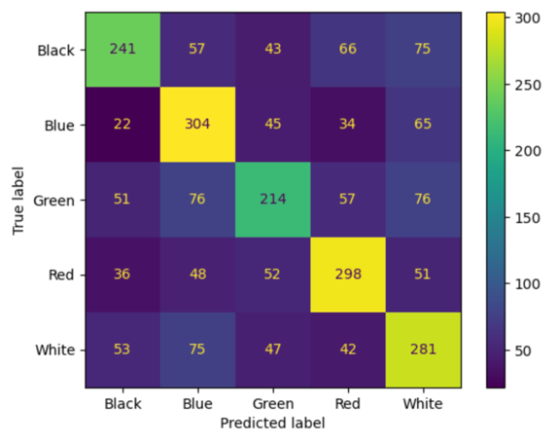

The second Multinomial Naïve Bayes model was trained and tested on the data created by the CountVectorizer function with max_features set to 350. The overall accuracy of the model when tested against the hold-out test data was 55.75%. Including 100 more word features as inputs only resulted in a miniscule increase in overall accuracy. The confusion matrix (Fig. 93) looks largely the same as the previous, with the model performing better for some colors and worse for others. For example, the number of black cards classified correctly decreased by 1 and the number of red cards classified correctly increased by 3. Just increasing the number of word features does not improve the performance of the model. Other types of changes will need to be made to get predictions that are more accurate.

**Figure 93) Confusion Matrix for MultinomialNB (CV with max_features = 350)**

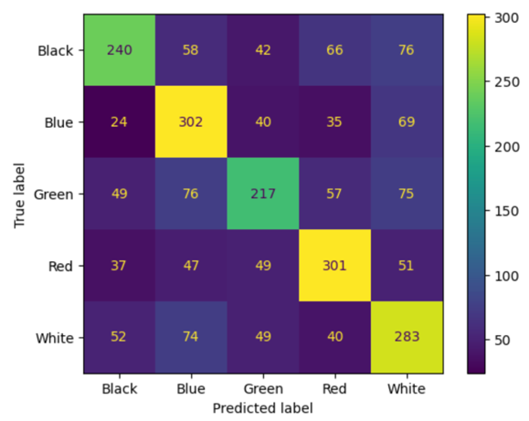

Next, the Bernoulli Naïve Bayes model was trained and tested on the data created by the binary CountVectorizer function with max_features set to 250. The overall accuracy of the model when tested against the hold-out test data was 55.21%. This accuracy is again very similar to the accuracies of the previous Multinomial Naïve Bayes models. The binary word features were slightly less informative overall, with the model making a few more mistakes in total. The confusion matrix for this model (Fig. 94) looks almost identical to the previous ones. The only differences are some variations in the number of classifications that were right and wrong for each color and there were not any significant deviations in the distributions of guesses among the colors.

**Figure 94) Confusion Matrix for BernoulliNB (Binary CV with max_features = 250)**

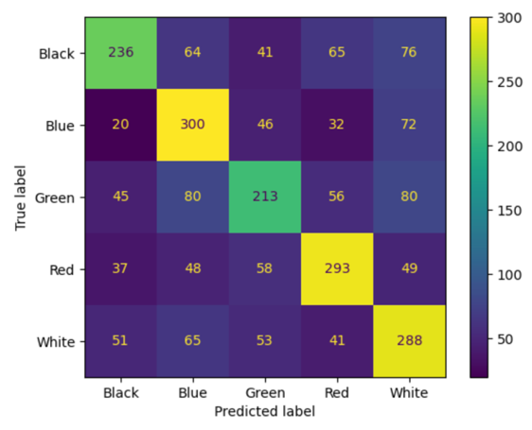

Then, the Bernoulli Naïve Bayes model was trained and tested on the data created by the binary CountVectorizer function with max_features set to 350. The overall accuracy of the model when tested against the hold-out test data was 56.50%. Increasing the number of word features for this model type improved the accuracy more than it did for the Multinomial Naïve Bayes model, but this increase is still quite small. This model is a strict improvement over the previous model. As seen in the confusion matrix (Fig. 95), the model got more classifications correct for all the colors compared to the first Bernoulli Naïve Bayes model. When using the binary data, there is no advantage to using the smaller number of input features.

**Figure 95) Confusion Matrix for BernoulliNB (Binary CV with max_features = 350)**

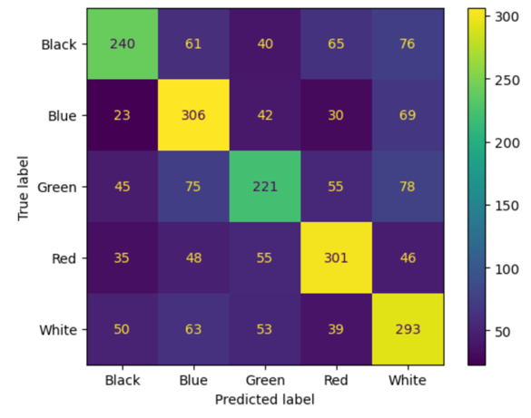

Next, the Multinomial Naïve Bayes model was trained and tested on the data created by the TfidfVectorizer function with max_features set to 250. The overall accuracy of the model when tested against the hold-out test data was 56.95%. Changing to the term frequency-inverse document frequency values provided a greater increase in accuracy than increasing the number of word features when compared to the first Multinomial Naïve Bayes model. The confusion matrix (Fig. 96) is similar to the previous ones, in that the model is making most of the predictions for each color correctly. When the model makes an incorrect prediction when classifying the green cards, it mistakes them as being blue most often. Also, when classifying the black and blue cards, the model mistakes them as being white most often.

**Figure 96) Confusion Matrix for MultinomialNB (TfidfV with max_features = 250)**

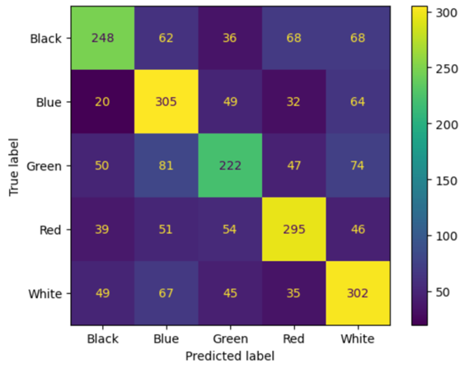

Lastly, the Multinomial Naïve Bayes model was trained and tested on the data created by the TfidfVectorizer function with max_features set to 350. The overall accuracy of the model when tested against the hold-out test data was 56.99%. Increasing the number of word features resulted in just a 0.04% increase in accuracy. This reinforces the conclusion that the accuracy gains came from changing the type of numerical value provided to the model and not by giving it more input features. This model is also not a strict improvement over the previous one as seen in the confusion matrix (Fig. 97). While this model classified more of the white, red, and green cards correctly, it classified one more of the black cards incorrectly and five more of the blue cards incorrectly.

**Figure 97) Confusion Matrix for MultinomialNB (TfidfV with max_features = 350)**

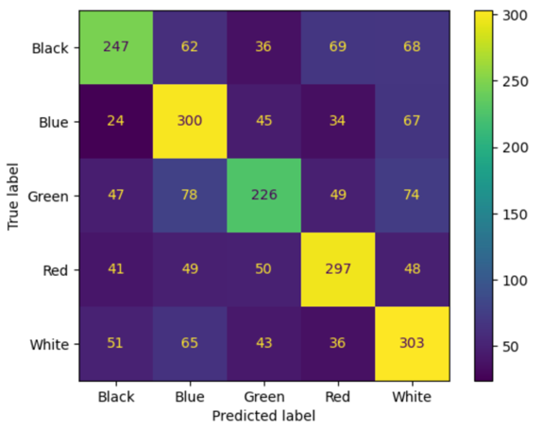

#### English and MtG Stop Words Removed

This Multinomial Naïve Bayes model was trained and tested on the data created by the CountVectorizer function with max_features set to 250. The overall accuracy of the model when tested against the hold-out test data was 57.26%. Removing the common MtG words that were prevalent across all the colors resulted in an approximate 2% increase in accuracy over the corresponding model with only English stop words removed. While this model gets most of its predictions within each color correct, as seen in the confusion matrix (Fig. 98), it has more trouble classifying the green and white cards than some of the other models. This time more white cards are being mistaken as blue, and there are just generally more errors being made when classifying the green cards.

**Figure 98) Confusion Matrix for MultinomialNB (CV with max_features = 250)**

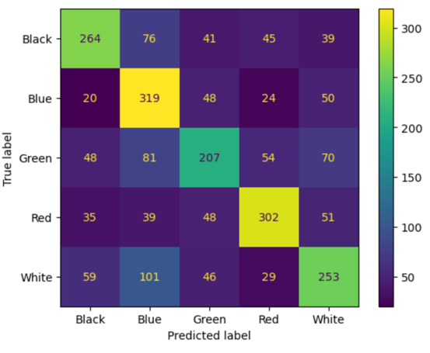

Next, the Multinomial Naïve Bayes model was trained and tested on the data created by the CountVectorizer function with max_features set to 350. The overall accuracy of the model when tested against the hold-out test data was 57.50%. Once again, just increasing the number of word features results in a very minimal increase to the overall accuracy. This model is not strictly better than the previous one as seen by the confusion matrix (Fig. 99). The number of black and white cards correctly classified increased, while the number of blue, green, and red cards correctly classified decreased. Also, even though more white cards were classified correctly, the number that were mistaken as blue increased by one. This model is not actually performing better than the previous model despite the accuracy statistic increasing.

**Figure 99) Confusion Matrix for MultinomialNB (CV with max_features = 350)**

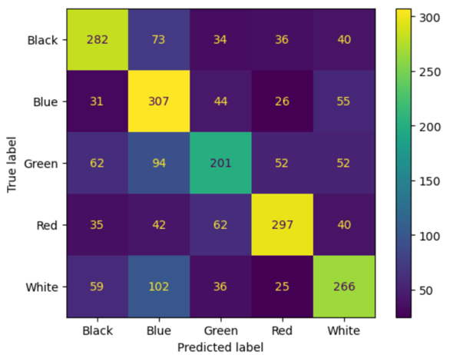

Now, the Bernoulli Naïve Bayes model was trained and tested on the data created by the binary CountVectorizer function with max_features set to 250. The overall accuracy of the model when tested against the hold-out test data was 56.98%. This time, the binary data performed slightly worse than the count data at this number of word features. The confusion matrix (Fig. 100) still shows that the most predictions are being made correctly along the diagonal of the matrix. Despite having lower overall accuracy, this model classifies more of the blue, green, and red cards correctly compared to the previous Multinomial Naïve Bayes model with 350 word features. Also, using the binary data resulted in less white cards being mistaken as blue.

**Figure 100) Confusion Matrix for BernoulliNB (Binary CV with max_features = 250)**

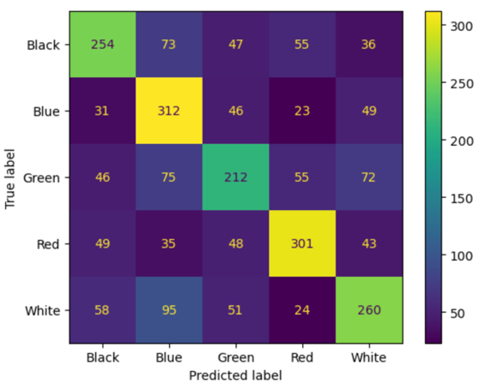

Then, the Bernoulli Naïve Bayes model was trained and tested on the data created by the binary CountVectorizer function with max_features set to 350. The overall accuracy of the model when tested against the hold-out test data was 58.17%. This represents a new high mark for the accuracies achieved by the models tested thus far. Increasing the number of word features resulted in more black, red, and white cards being classified correctly, but fewer blue and green cards classified correctly as seen in the confusion matrix (Fig. 101). There was also a significant decrease in the number of white cards being classified as blue, although the model still thinks that white and green cards are blue too often. The number of cards correctly predicted as being green is less than in many of the other models, but the model is now getting around 300 predictions for all the other colors correct. This seems to be a great option for overall performance among all the Naïve Bayes models produced up to this point.

**Figure 101) Confusion Matrix for BernoulliNB (Binary CV with max_features = 350)**

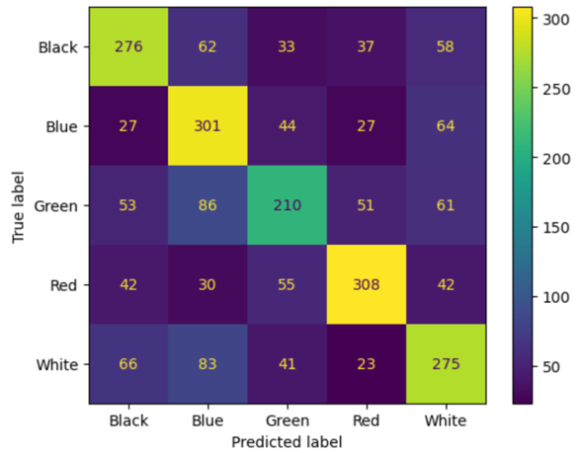

Then, the Multinomial Naïve Bayes model was trained and tested on the data created by the TfidfVectorizer function with max_features set to 250. The overall accuracy of the model when tested against the hold-out test data was 57.34%. With the MtG stop words removed, the term frequency-inverse document frequency data did not result in the most performant model. The actual predictions of the model, as seen in the confusion matrix (Fig. 102), are not significantly different from any of the previous results either. Based on the similarity of these results to previous results, there would be no reason to use this model over the Bernoulli Naïve Bayes model with 350 word features.

**Figure 102) Confusion Matrix for MultinomialNB (TfidfV with max_features = 250)**

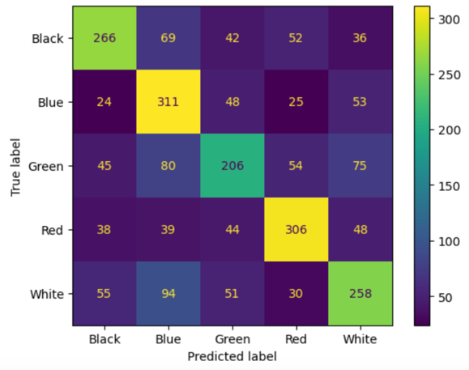

Lastly, the Multinomial Naïve Bayes model was trained and tested on the data created by the TfidfVectorizer function with max_features set to 350. The overall accuracy of the model when tested against the hold-out test data was 57.76%. This model also did not perform as well as the Bernoulli Naïve Bayes model using the same number of word features. Comparing the results of this model (Fig. 103) to that Bernoulli Naïve Bayes model shows that while there was an increase in the number of black cards correctly classified, there was a decrease in the number of white cards correctly classified. Also, the number of white cards that were mistaken as being blue increased. The number of green cards that were mistaken as being blue increased as well. Overall, this model provided pretty good results, but it is not as accurate as the best performing Bernoulli Naïve Bayes model.

**Figure 103) Confusion Matrix for MultinomialNB (TfidfV with max_features = 350)**

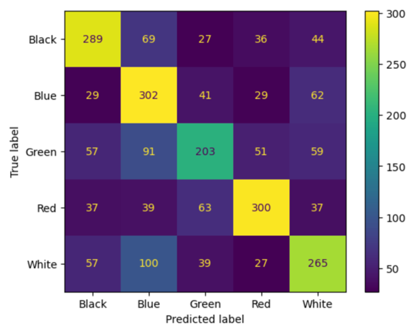

#### No Stop Words Removed

First, the Multinomial Naïve Bayes model was trained and tested on the data created by the CountVectorizer function with max_features set to 250. The overall accuracy of the model when tested against the hold-out test data was 54.42%. While this is the lowest accuracy so far, the model performed surprisingly well considering no words were removed from the pool of potential word features during the vectorization step. Using this data also resulted in less blue and green cards being mistaken as white cards, as seen in the confusion matrix (Fig. 104). While this model would not be used due to it being approximately 4% less accurate than the best model so far, it is interesting to see that some of the commonly removed stop words can be informative features for this task.

**Figure 104) Confusion Matrix for MultinomialNB (CV with max_features = 250)**

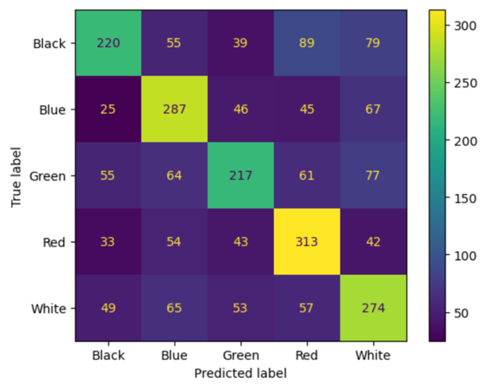

Next, the Multinomial Naïve Bayes model was trained and tested on the data created by the CountVectorizer function with max_features set to 350. The overall accuracy of the model when tested against the hold-out test data was 55.42%. By providing the model an additional 100 word features, it has reached the about the same overall accuracy as the 250 word feature models with the English stop words removed. This model has the most trouble classifying green and black cards, but is still getting the majority of its predictions correct as seen in the confusion matrix (Fig. 105). Once again, not removing stop words has resulted in lower numbers of green and white cards being classified as blue. Interestingly, the only color that the model predicted correctly less often when being given more word features was red.

**Figure 105) Confusion Matrix for MultinomialNB (CV with max_features = 350)**

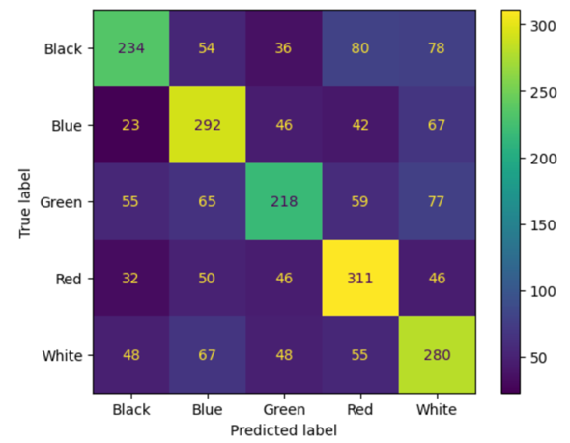

Now, the Bernoulli Naïve Bayes model was trained and tested on the data created by the binary CountVectorizer function with max_features set to 250. The overall accuracy of the model when tested against the hold-out test data was 54.75%. Using the binary data was again slightly better than the count data for the same number of word features. This model has one of the highest accuracies when predicting the white cards out of all the experiments done so far, as seen in the confusion matrix (Fig. 106). This model does, however, see a reduction in the accuracy related to the black cards to almost the same level as the green cards. The numbers of blue, green, and red cards correctly classified are slightly lower than many of the other models as well.

**Figure 106) Confusion Matrix for BernoulliNB (Binary CV with max_features = 250)**

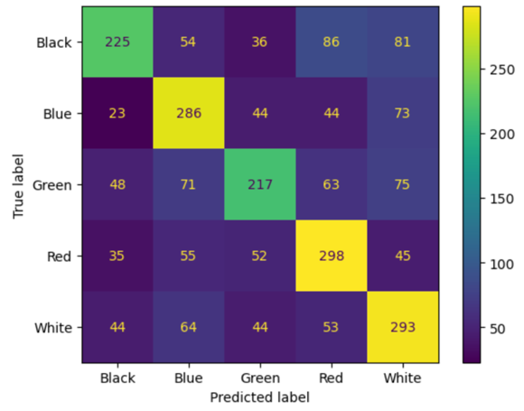

Next, the Bernoulli Naïve Bayes model was trained and tested on the data created by the binary CountVectorizer function with max_features set to 350. The overall accuracy of the model when tested against the hold-out test data was 55.17%. When increasing the number of word features this time, the binary data did not perform as well as the count data. Although there was a small increase in accuracy when compared to the previous model, the confusion matrix (Fig. 107) looks very similar. This model classified three more of the black cards, three more of the green cards, and four more of the white cards correctly. This model would not be preferred to any of the models created with all the stop words removed, but these results are showing that there is something about the way the white cards are written that the presence of certain stop words can be used to identify them.

**Figure 107) Confusion Matrix for BernoulliNB (Binary CV with max_features = 350)**

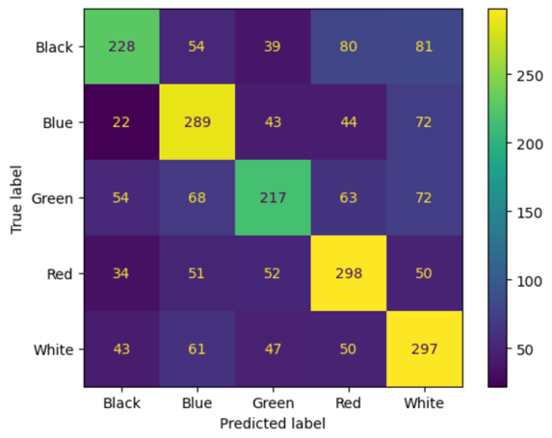

Then, the Multinomial Naïve Bayes model was trained and tested on the data created by the TfidfVectorizer function with max_features set to 250. The overall accuracy of the model when tested against the hold-out test data was 56.25%. As with the English stop words, the term frequency inverse-document frequency values provided a strict improvement in terms of the accuracy of the Multinomial Naïve Bayes models, as seen in its confusion matrix (Fig. 108). Aside from having the highest accuracy of the models using the no stop words data so far, the number of white cards being correctly classified remained very high, while also seeing improvements in the classifications of the other colors as well. This model also has one of the highest rates of green cards correctly classified out of all the models. From these results, it seems that including the stop words does afford benefits for certain card colors.

**Figure 108) Confusion Matrix for MultinomialNB (TfidfV with max_features = 250)**

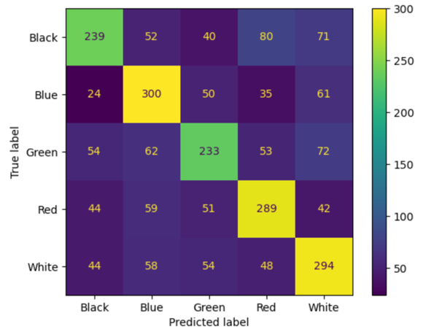

Lastly, the Multinomial Naïve Bayes model was trained and tested on the data created by the TfidfVectorizer function with max_features set to 350. The overall accuracy of the model when tested against the hold-out test data was 57.16%. This model had the highest accuracy of all the models using the no stop words data. This accuracy actually surpassed the highest performing model using the English stop words data, but is about 1% less accurate overall when compared to the best performing model using the additional MtG stop words. The confusion matrix for this model (Fig. 109) again shows that the stop words are providing benefits for the model’s ability to correctly classify the white cards. The other colors were classified correctly at about the same rates as the previous models. This time, the greatest number of mistakes came from the model classifying either a black card as white or red, or a green card as being white.

**Figure 109) Confusion Matrix for MultinomialNB (TfidfV with max_features = 350)**

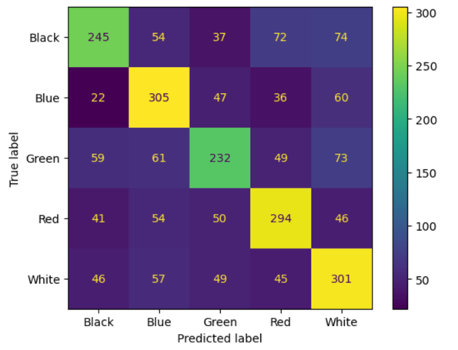

### Unigram and Bigram Naïve Bayes Classification Model

To assess if including bigrams (consecutive word pairs) in the input features of the models might be more informative, this type of word feature was included for the best performing Naïve Bayes model. The Bernoulli Naïve Bayes model with its max_features parameter set to 350 was given unigram and bigram word features using data created by the binary CountVectorizer function. This resulted in an overall accuracy of 57.27%. This accuracy is about 1% lower than the accuracy of the corresponding model using only unigram word features. It is important to note that this confusion matrix (Fig. 110) cannot be directly compared to those of the previous models. In the data preparation stage, many more rows of data were removed when filtering out the rows with all zero values. This is due to pairs of specific words naturally occurring less frequently in any given text compared to single words. This means the total number of cards in both the training and testing sets were lower, resulting in lower numbers in the confusion matrix overall. This model also does a better job of correctly classifying the white cards, but this seems to have correlated with worse accuracy when classifying the green cards. Based on this result, there is not a strong reason to use unigram and bigram data over just the unigram data.

**Figure 110) Confusion Matrix for BernoulliNB (Binary CV with max_features = 350)**

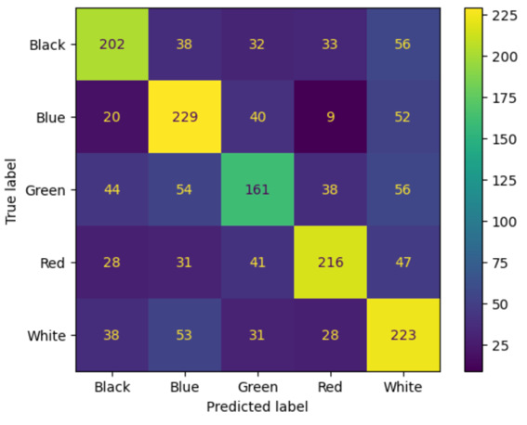

### Discussion of Naïve Bayes Models Results

All the Naïve Bayes models performed rather similarly with almost all the accuracies in the upper 50s. These models provided a good starting point for the analysis, and showed that it is possible to classify the cards according to their color using a machine learning algorithm. Although none of the models had a high overall accuracy that would be impressive from a purely numerical standpoint, like 85% or 90% accuracy, they performed admirably when taking into account the complexity of the classification. This task requires the model to choose between five different classes, which is much more difficult than if it was only trained and tested on cards of only two different colors.

Multicolor cards are also featured in MtG. This would be a card such as Absorb, shown in Figure 111, which requires one white mana and two blue mana to play. While multicolor cards were not used in the analysis, this means that a certain amount of overlap between the functions that different color cards can perform is an intentional part of the game design. This explains why the models would have difficulty differentiating between white and blue cards or any other combination of two colors that are frequently seen in multicolor cards since those two colors would have at least one shared ability between them.

**Figure 111) White and Blue Multicolor Card, Absorb**

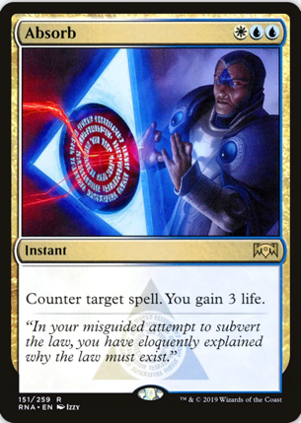

*Source: https://scryfall.com/card/rna/151/absorb*

Although some combinations of stop words and model types resulted in certain advantages and disadvantages, the models using the data where the English stop words and the MtG stop words were removed performed the best overall. Each of these models had higher accuracy than their corresponding models using the English stop words only or no stop words. Among the models using the English and MtG stop words, the Bernoulli Naïve Bayes model with 350 word features performed the best with an accuracy of 58.17%. These results provided the basis for the subsequent classification model experiments. The following models would use the English and MtG stop words data to see if other types of machine learning algorithms could further improve the accuracy of the predictions.

### Decision Tree Classification Models

All the following decision tree classification models were trained and tested using data where the English and MtG stop words were removed. The decision trees were compared across the different vectorization values used in the Naïve Bayes models experiments: CountVectorizer count data, CountVectorizer binary data, and TfidfVectorizer data. Each of the following subsections discusses the results using those various types of numerical values as inputs.

#### CountVectorizer Data

The first decision trees were built using the data created by the CountVectorizer function with the max_features parameter set to 350. The model was trained and tested at three different maximum depths: 8, 10, and 12. When outputting the actual decision tree for the shallowest depth model, it was immediately clear that the greatest advantage of the decision tree models, their interpretability, would not be an advantage for this classification task. Due to the number of output classes being predicted, even the shallowest tree (Fig. 112) is so complex that neither the labels or boundary values are displayed when creating the image in Python. Even if the decision tree was legible, this would be far too complicated of a system to be useful to a game designer. The use of any flow chart built from this model would likely slow down the game development process rather than accelerate it. Since viewing the decision trees is not informative about how the model is actually making decisions, only the confusion matrices will be shown moving forward.

**Figure 112) Decision Tree Model Output (max_depth = 8)**

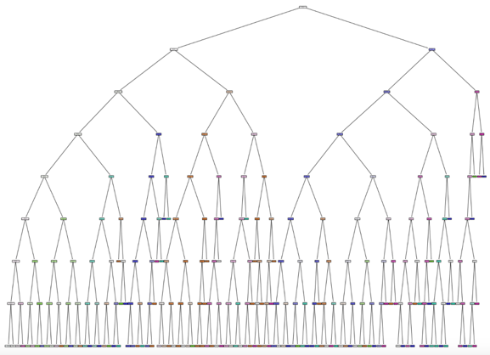

Despite the complexity of the decision tree, this first model had significantly lower accuracy than any of the Naïve Bayes models, at only 42.67%. Looking at the confusion matrix (Fig. 113) shows that this model is very biased towards classifying a card as green, regardless of the card’s actual color. Only blue and red cards are predicted correctly more often than they are predicted as being green. This model is definitely unusable as an aid in the game development process.

**Figure 113) Confusion Matrix for Decision Tree (max_depth = 8)**

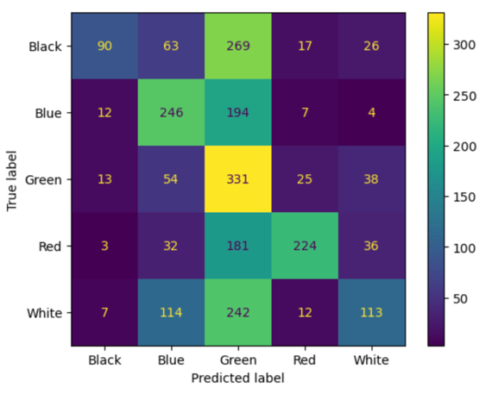

Increasing the depth of the decision tree to 10, resulted in a very different confusion matrix (Fig. 114), but it actually had the same overall accuracy of the previous model, at 42.67%. Now the decision tree is very biased towards thinking that a card is white, regardless of its actual color. Once again, the only colors that are predicted correctly more often than being predicted as white are blue and red. This model would also not be viable for this classification task.

**Figure 114) Confusion Matrix for Decision Tree (max_depth = 10)**

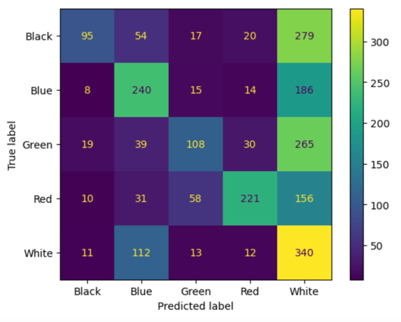

Increasing the depth of the decision tree once more to 12, resulted in an overall accuracy of 45.77%. While the accuracy increased by about 3%, it is still far below an acceptable level. Also, looking at the confusion matrix (Fig. 1115) reveals that this model still has the problem of thinking almost all the cards are white. With a depth of 12, it is significantly better at identifying red cards and black cards, but is worse at identifying the blue cards. Regardless of specific changes to the predictions made on certain card colors, this model would not be used to complete this classification task.

**Figure 115) Confusion Matrix for Decision Tree (max_depth = 12)**

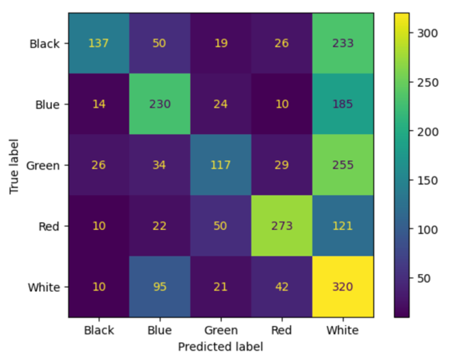

#### Binary CountVectorizer Data

The next set of decision trees were created using the binary CountVectorizer data with the max_features parameter set to 350. Starting with the max_depth parameter of the decision tree set to 8, this model had an overall accuracy of 42.55%, performing even worse than the previous decision trees. This model is even more biased towards classifying every card as being white, as seen in the confusion matrix (Fig. 116). Previously, more blue cards were classified correctly, but now the only color other than white with more correct predictions than incorrect predictions is red. While the predictions made on the white cards are nearly perfect, this model is also completely unusable for this classification task.

**Figure 116) Confusion Matrix for Decision Tree (max_depth = 8)**

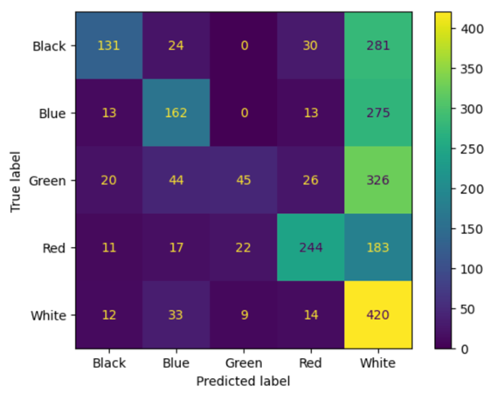

Increasing the depth of the decision tree to 10, resulted in an overall accuracy of 45.27%. This accuracy is almost as high as the decision tree with a max_depth parameter of 12 using the CountVectorizer data. Curiously, this increase in depth has correlated with the model switching to again being biased towards predicting the cards as being green regardless of their actual color, as seen in the confusion matrix (Fig. 117). This time, however, both the red and blue cards were correctly predicted more often than being classified as green. Regardless of which color the model is biased towards, this decision tree still performs far too poorly to be used to classify the cards by their color.

**Figure 117) Confusion Matrix for Decision Tree (max_depth = 10)**

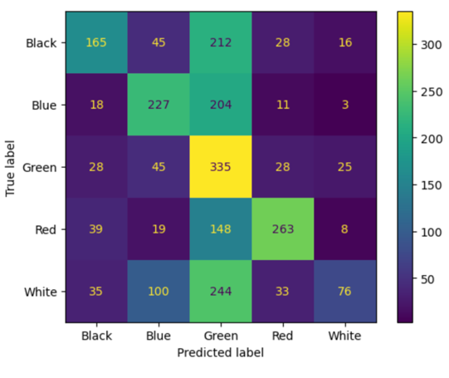

Increasing the depth of the decision tree once more to 12 resulted in an overall accuracy of 46.28%. While this is the highest overall accuracy of any decision tree so far, it is still well below the baseline set by the Naïve Bayes models. The results of this model have changed again, as seen in the confusion matrix (Fig. 118), with the model now overpredicting that cards are white, rather than their actual color. Similar to the other decision trees, the model does correctly classify more of the blue and red cards as their actual color, rather than white, but this one makes many more mistakes when it comes to the cards that are actually white. This model has the same issue as the Naïve Bayes models where the white cards are mistaken as being blue. As with the other decision tree models, this one is not suitable for this classification task.

**Figure 118) Confusion Matrix for Decision Tree (max_depth = 12)**

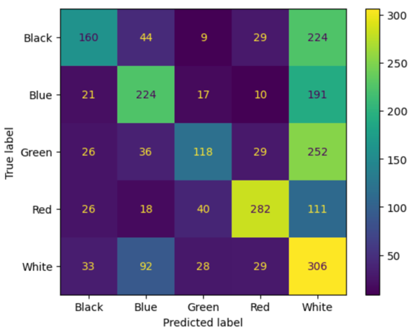

#### TfidfVectorizer Data

The third set of decision trees were created using the TfidfVectorizer data with the max_features parameter set to 350. Starting with the max_depth parameter of the decision tree set to 8, this model had an overall accuracy of 42.07%. This is the worst overall accuracy of all the decision trees so far. The confusion matrix for this decision tree (Fig. 119) shows that there is again a significant bias towards classifying all the cards as being green regardless of their actual color. Other than the green cards themselves, only the red cards are classified as being their actual color more often than green. As with the other decision trees, this model is not up to completing this classification task.

**Figure 119) Confusion Matrix for Decision Tree (max_depth = 8)**

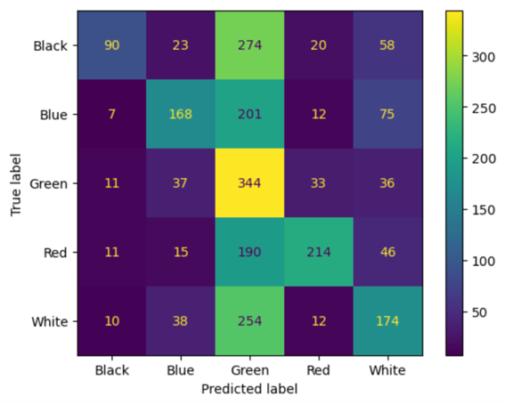

Increasing the depth of the decision tree to 10, resulted in an overall accuracy of 42.97%. These decision trees are continuing to perform worse than their counterparts using the binary CountVectorizer data. Increasing the depth has changed the model’s bias back to being towards the color white, as seen in the confusion matrix (Fig. 120). Once again, only the red cards are being predicted as their actual color more often than being incorrectly predicted as white. There is no advantage to using this model over any of the other decision trees and it does not meet the standard set by the Naïve Bayes models. This decision tree would not be used to classify the cards by their colors.

**Figure 120) Confusion Matrix for Decision Tree (max_depth = 10)**

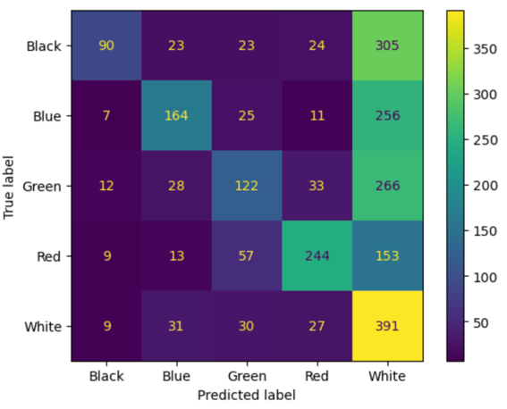

Increasing the depth of the decision tree to 12 resulted in an accuracy of 44.92%. This is about 2% more accurate than the previous model, but still worse than the corresponding model using the binary CountVectorizer data. The confusion matrix (Fig. 121) reveals that this model is again biased towards thinking that all the cards are white, but is starting to get more of the predictions for the other colors correct. A secondary pattern is highlighted along the diagonal showing that when the model is not guessing white for a particular color of card, it is actually choosing the right color most of the time. While this result is better than some of the decision trees, the performance is still very poor, and it cannot be used to complete this classification task.

**Figure 121) Confusion Matrix for Decision Tree (max_depth = 12)**

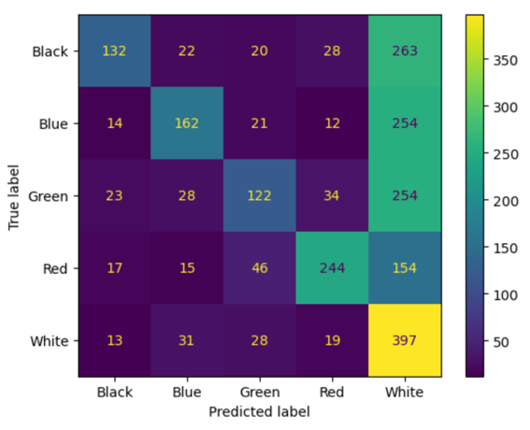

### Discussion of Decision Tree Results

All the decision tree models performed significantly worse than the Naïve Bayes models and none were viable for completing the classification task. Since decision tree models take longer to train and test than Naïve Bayes models, the main advantage to using this model type is the transparent look it provides into its decision-making process. However, since this classification task has five target classes to choose from, the trees are far too complex to be useful or interpretable. The decision trees did all slightly improve in accuracy as their maximum depths were increased, which implies that if the trees were allowed to grow without any limitations, then the accuracy could continue to improve. This would defeat the point of using this type of model, however, as the tree might get to dozens of levels of depth and take significantly longer to run.

Attempting to further tune this type of model is likely not a good use of time because the game design team would not learn anything new from its use. At least with the Naïve Bayes models, the users could look at the most informative features and quickly understand some of the logic behind the model’s decisions. Printing a legible version of these decision trees would result in a massive, complex web of decisions that would require too much work both to follow and implement in terms of a design flowchart tool. For these reasons, this model type will no longer be considered as viable for this classification task.

### SVM Classification Models

The SVM models were also trained and tested using the data where the English and MtG stop words were removed. Due to the fact that this analysis was being run on local hardware and that SVM models take significantly longer to train and test, the 250 word feature versions of the data were used for the model comparison process. For the CountVectorizer, binary CountVectorizer, and TfidfVectorizer data, three different SVM models were built: one using the linear kernel, one using the polynomial kernel, and one using the radial basis function (RBF) kernel. Once the top performing model was identified, it was re-run using the 350 word feature version of the data to see how much the accuracy would improve.

#### CountVectorizer Data

The first SVM model created using the CountVectorizer data used the linear kernel. This model had an overall accuracy of 61.00%, immediately surpassing the best of the Naïve Bayes models by about 3%. The predictions of this model (Fig. 122) look similar to the Naïve Bayes results, but just better. There are less occurrences of the white cards being mistaken as blue. The model is classifying more of the black cards correctly and it is still getting very high numbers of blue and red cards correct. This model is certainly the best so far and does not have any disadvantages compared to the previous models as long as the user has the computational power to run this model type in a reasonable amount of time.

**Figure 122) Confusion Matrix for Linear SVM**

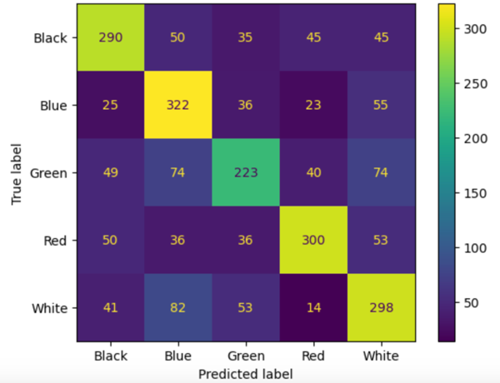

Changing to the polynomial kernel resulted in an overall accuracy of 60.62%. While the accuracy of this model is lower than the previous, the results of this one feel more balanced. The confusion matrix (Fig. 123) shows a big increase in accuracy when classifying the green cards. Although the accuracy as related to some of the other colors has decreased, the confusion matrix heat map colors along the diagonal are much more even. This model also performs best when predicting the white cards and does not make most of its errors for this color predicting them as being blue. While this model is not necessarily better or worse than the previous model, it provides a different option depending on what color might need to be prioritized.

**Figure 123) Confusion Matrix for Polynomial SVM**

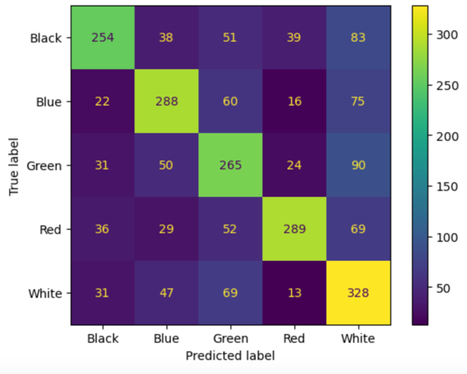

Changing the kernel to RBF resulted in a model with an overall accuracy of 63.26%. This model has the best accuracy of all the models so far, but is much more uneven in terms of its predictions, especially compared to the polynomial kernel SVM. The confusion matrix (Fig. 124) reveals that the accuracies when classifying the blue and red cards are very high, and the model is doing better when classifying the black cards as well. This model is significantly worse at classifying the green and white cards however, having a similar weak point as many of the Naïve Bayes models. So even though the accuracy is higher, it cannot be said that this model would be preferred over the models with the other kernels in every situation.

**Figure 124) Confusion Matrix for RBF SVM**

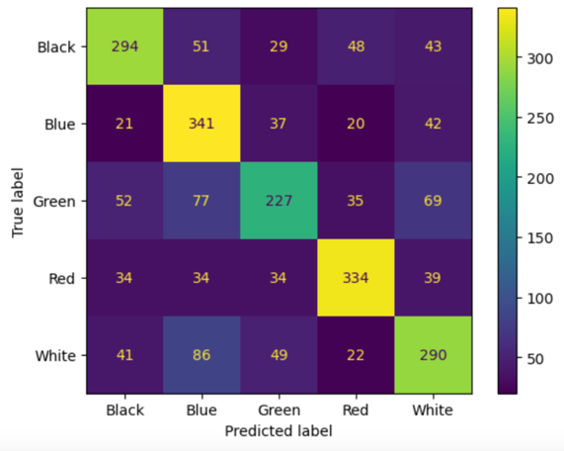

#### Binary CountVectorizer Data

The first SVM model created using the binary CountVectorizer data used the linear kernel. This model had an overall accuracy of 60.51%, ranking it slightly below the corresponding SVM using the regular CountVectorizer data. This model makes quite a few mistakes when classifying the green and white cards, as seen in the confusion matrix (Fig. 125), but again performs pretty well overall. All the correct classification numbers hover around 300, with the exception being the green cards, but that has generally been the worst performing class in all the models. There are no significant advantages or disadvantages to using the binary data with the linear SVM versus using the count data, but in either case this is not the best performing kernel anyway.

**Figure 125) Confusion Matrix for Linear SVM**

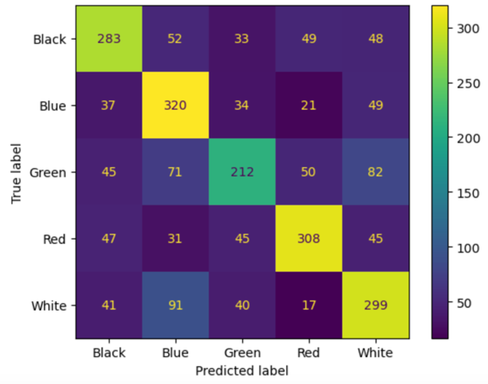

The polynomial kernel SVM model created using the binary CountVectorizer data had an overall accuracy of 61.53%. This is an improvement both over the previous model and the corresponding model using the count data. The confusion matrix (Fig. 126) reveals that this model does a much better job at classifying the green cards than the previous model, but loses a substantial amount of accuracy when classifying the blue cards. This trade-off in performance explains why the overall accuracy is only slightly higher. Overall, this model also performs well, but it is not necessarily an improvement over the linear kernel model.

**Figure 126) Confusion Matrix for Polynomial SVM**

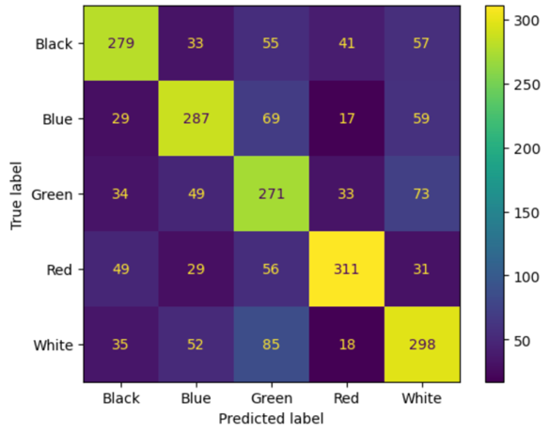

Changing the kernel to RBF again resulted in the highest accuracy model for this data, scoring 64.21%. This is again a new high mark for the accuracies of all the models. All the colors, except for green, have over 300 of the cards classified correctly. This is a substantial improvement in terms of raw accuracy and the consistency of the predictions across the colors when compared to any of the other models, as seen in the confusion matrix (Fig. 127). While it still retains some of the disadvantages of the other models, such as it mistaking a fair number of the white cards as being blue, it certainly produces an impressive result overall. Considering that there are five classes for the model to choose from, it is about 44% more accurate than random guessing. This is likely approaching the level of performance where this model could actually be used for the classification task with good results. Since the model would be used by someone who has extensive knowledge of the game, they would likely only need help deciding between one of two possible colors for a card. Using the results of the model compared to their own thoughts, they could more informatively choose a single color or decide to make it a multicolor card.

**Figure 127) Confusion Matrix for RBF SVM**

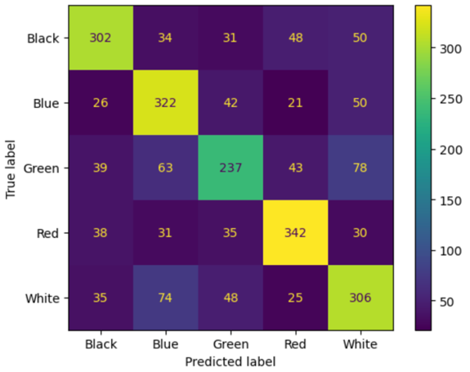

#### TfidfVectorizer Data

The final set of SVM models were trained and tested using the data created by the TfidfVectorizer function. The first model used the linear kernel and had an overall accuracy of 60.58%. This model performs slightly better than its counterpart using the binary data, but slightly worse than the linear kernel with the count data. The results of this model (Fig. 128) are very similar to the results of the other SVM models. Green cards are still the hardest for the model to correctly classify, and when a white card is classified incorrectly it is more likely to be labeled as blue than another color. The accuracy when classifying the blue and red cards remains the highest.

**Figure 128) Confusion Matrix for Linear SVM**

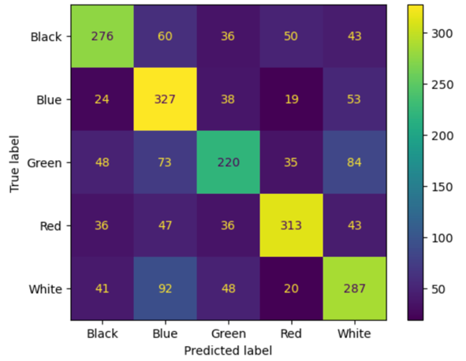

Next, the kernel was changed to polynomial, and this resulted in an overall accuracy of 61.39%. Once again, this accuracy is in between those when the binary and count data were used. The predictions made by this model (Fig. 129) are again very similar to the other SVM models. Compared to the previous model with the linear kernel, however, the model classifies slightly less of the white cards as being blue. The number of green cards correctly classified is also greater, but this model is worse at correctly classifying the blue cards. This model does not offer any specific advantages and does not achieve the level of performance set by the RBF kernel models.

**Figure 129) Confusion Matrix for Polynomial SVM**

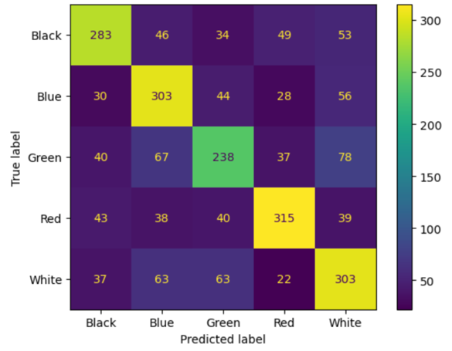

Running the SVM model with the RBF kernel resulted in an overall accuracy of 63.64%. As with the other models using the TfidfVectorizer data, that accuracy metric is lower than the corresponding model using the binary data, but higher than the corresponding model using the count data. The performance of this model is better than the other kernels for this data type as seen in the confusion matrix (Fig. 130). The model is having the most trouble classifying the green cards which is bringing down the overall accuracy. Excluding the green cards, the model is about 68% accurate overall. This is again a satisfactory level of performance for completing this classification task, but there is no reason to choose this model over the previous RBF model that a little more than 0.5% more accurate.

**Figure 130) Confusion Matrix for RBF SVM**

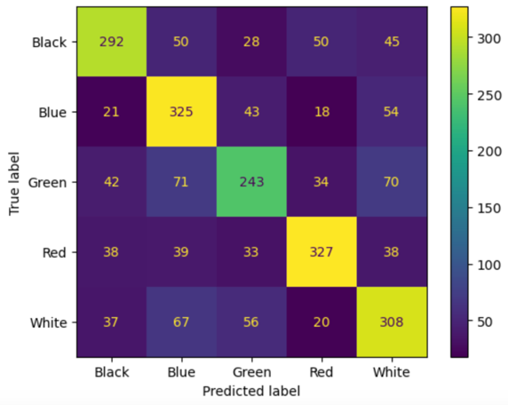

#### RBF SVM with 350 Word Feature Binary Data

The RBF kernel SVM using the data created by the binary CountVectorizer function was trained and tested one more time using the version of the data when the max_features parameter of that CountVectorizer function was set to 350. The resulting model had an overall accuracy of 65.27% when tested against the hold-out testing data. As seen in the confusion matrix (Fig. 131), this is simply the best model out of all the ones produced in this analysis. This model has the highest overall accuracy and is the most consistent across the various colors. The model got more than 300 classifications correct for all the colors, except for green, which is a first during this analysis. This model provides the best results for classifying the black cards as well as close to the best results for the blue and red cards. Even though it may be outclassed by other models in a specific area, this model has produced the best confusion matrix overall. This model could certainly be used to complete this classification task, especially when used with the knowledge that it is weaker at classifying the green cards and when used by someone who is as familiar with MtG as a game designer would be.

**Figure 131) Confusion Matrix for RBF SVM (TfidfV with max_features = 350)**

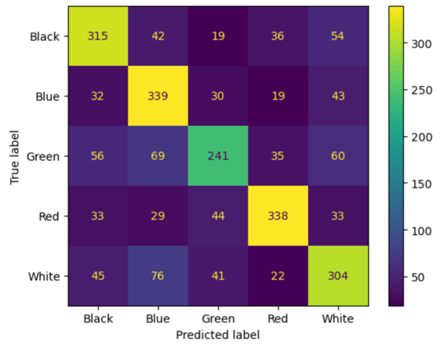

#### Testing Unigram and Bigram Data

The final SVM model created for this analysis used the unigram and bigram data created by the binary CountVectorizer function with its max_features parameter set to 350. This model was intended to be directly compared to the previous RBF SVM with 350 word features that scored the highest accuracy so far. This overall accuracy of this model is almost identical at 65.22%. The accuracy metric does not tell the whole story however. While this confusion matrix (Fig. 132) cannot be directly compared to the previous due to the number of cards being included in the training and testing data when any rows with all zero values were removed, the distribution of correct classifications in each color are more uneven. The model performs better when classifying the blue cards, but not as well with the other colors. Since this model takes longer to run than the unigram version, has just slightly lower accuracy, and has more variations in its predictions, it would not be preferred over the unigram RBF SVM using the binary CountVectorizer data with the max_features parameter set to 350.

**Figure 132) Confusion Matrix for RBF SVM (Unigram and Bigram binary CV with max_features = 350)**

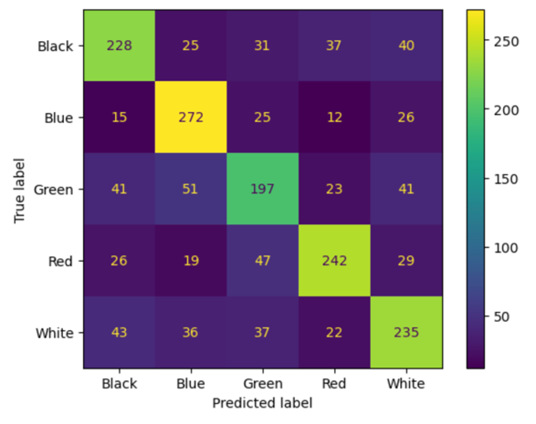

### Discussion of SVM Results

All the SVM models had higher accuracy than the other classification model types. These were certainly best suited to completing this classification task with this type of text data used as inputs. In general, the linear kernel models performed the worst, just slightly below the polynomial kernel models. The RBF kernel models performed the best, with no apparent weaknesses compared to the other kernels. They achieved the highest levels of overall accuracy in the entire analysis, and made the most consistent predictions across the various card colors. None of the SVM models exhibited any strange behavior, such as attempting to classify almost all the cards as either green or white regardless of their color.

While there is not too much to discuss regarding the results of the SVM experiments, this is due to the overall quality of those results. These models reached an acceptable level of performance and can complete the classification task. Even at the current level of performance, that RBF SVM could be used to double check the work of the game designers and help them understand if a card might be considered as being multicolor. That model also makes very few mistakes when classifying cards of opposing colors, such as red and blue. Within the game design space, those colors have different abilities and are played with very different strategies. As an example, that model classified only 19 of the blue cards as being red. These results also inspire confidence that further adjustments could be made to the input text to improve the overall accuracy of the model even more.

### Final Result of Classification Models and Next Steps

After analyzing the results of all the classification models, the RBF SVM using the binary CountVectorizer data with 350 word features would be chosen as the basis for the game development aid. It would be very interesting to see how this model performs on an unreleased set of cards that the game developers are working on. The accuracy of the model when it is applied to the cards that are still in development would provide information on how well the model aligns with what the game developers are thinking. If it was substantially less accurate this could indicate that the design team has decided to majorly shift the themes of the game, or that those new cards need a lot more work before they are published.

While the performance is already at a good level, some further work could be done to improve the accuracy. One idea would be to continue to remove more MtG stop words. For example, the words “enters” and “gain” are also frequently found on the cards regardless of their color. Removing these words could continue to provide a similar performance gain as to when the initial round of MtG stop words were removed.

Another round of experiments that could be helpful would be training and testing a series of “head-to-head” models that only consider two colors at a time. This would give data to back up decisions regarding which colors should be used in combination for multicolor cards and which should not. In addition, these models would be helpful when a developer is unsure of which color to assign to a card when they are already fairly sure of what colors it could potentially be. These models could also serve as a secondary layer to the main model considering all the colors. If the designer had one color in mind, but the main model disagrees, that designer could run that card through the “head-to-head” model featuring those two colors as a tie breaker.

To further improve the model, it would also be interesting to train and test it using only cards released in certain sets or during years. This would give more information to how the game has evolved over time. Also, if the developers are trying to capture the feel of a certain past era with upcoming cards, they could use that corresponding model to help them assign colors to those cards.

### LDA Topic Modeling

For each set of cards, LDA was used to discover ten topics and produce the top ten words within each of those topics. Since the topics returned by the LDA algorithm are not named, the top words were taken in relation to one another and compared with known themes and storylines in the Magic: The Gathering universe in order to generate labels for each topic. The topics and topic names are not intended to be an exhaustive list of all the topics that are present in the flavor texts of the MtG cards, but to provide a surface level of insight into the major topics that the game designers have focused on while creating the histories behind the cards.

#### Modeling Topics from the Entire Set of Cards

The following ten topics, as shown in Figure 133, were discovered from the flavor texts of all the MtG cards imported for use in this analysis. The topics discovered focus on some of the main themes of MtG, but also include some color-specific themes.

MtG is all about summoning “Creatures” that the Planeswalkers use to “Battle” one another, so it is no surprise that these are the first two topics returned by the LDA model. The MtG universe also features many different locations, and the storylines featuring two of those, “Kamigawa” and “Alara” are shown below. Kamigawa is a plane that is ruled by Great Spirits and Alara is a plane where both humans and goblins live. Humans and goblins are known to have conflicts with one another. One of the expansions released in 1997, Weatherlight, had a large-scale storyline associated with it, and that topic has been discovered as the “Weatherlight Saga”. The storylines started in the Weatherlight saga continued until the release of the Apocalypse expansion in 2001. This storyline was a major part of the overall lore of MtG.

The themes from two of the MtG colors were discovered as well. “Dragons” and “Goblins”, primarily from the red cards, make up four of the ten topics discovered. The “Ruminations” topic likely comes from the blue cards and describes one of the main philosophies of how magic users achieve their powers from thought and introspection. “Planeswalker Urza” is one of the legendary planeswalkers who is most commonly associated with the blue color.

**Figure 133) Output from LDA Model with Topic Names (All Cards)**

Topic 1: **Battle**

time fear fight forest hand strength true mage shall captain

Topic 2: **Creatures**

good dead things eyes place path thought creatures doesn past

Topic 3: **Kamigawa**

know power long want flesh kami war soul flame night

Topic 4: **Weatherlight Saga**

left come heart earth single deep lightning dark tell weatherlight

Topic 5: **Dragon**

life way blood best thing dragons end eye follow saw

Topic 6: **Goblins**

just goblins make need think nature home did ground does

Topic 7: **Alara Human-Goblin Conflict**

great goblin day rage like lost enemy storm master rock

Topic 8: **Defense Against Dragons**

new battle little world away use living magic city dragon

Topic 9: **Planeswalker Urza**

don let sun land seen years die mountains live urza

Topic 10: **Ruminations**

like death mind sky sea run better got face stand

The following ten topics, as shown in Figure 134, were discovered from the flavor texts of the white cards. These topics focus on the religious themes and crusader personas featured in the white cards, as well as some of the storylines in the MtG universe. Many of the white creatures are featured as a type of holy soldier, making them very similar to crusaders. Naturally, their beliefs are filled with religious symbolism, and it is their faith that brings them victory in battle. One of the types of cat creatures, the Leonin, are most commonly found within the white cards. They generally take the form of anthropomorphic cat warriors and mages who are strongly aligned to the white mana.

The white cards also feature more of the story from the Weatherlight saga making reference to the actions of Gerrard Capashen, who is the main hero of the story. Another major character, Gideon Jura, is a topic found within the white cards. He is part of many stories and conflicts in the MtG universe, including some of those found within the Weatherlight saga and a more recent MtG expansion known as Shadows over Innistrad.

**Figure 134) Output from LDA Model with Topic Names (White Cards)**

Topic 1: **Crusaders**

world faith sword like shield little let soldiers come truth

Topic 2: **Weatherlight Saga**

place gerrard strike weatherlight righteous cause right free walk shields

Topic 3: **Religious Symbolism**

hope new soul best night don angel light just single

Topic 4: **Victorious Combat**

time better general victory magic think watch big warriors hearts

Topic 5: **Weatherlight Rebellion**

long know power blood life guard greater army law cho

Topic 6: **Great Spirit**

fight war peace kami follow home honor knights pride trained

Topic 7: **Gideon Jura**

need shall protect wings thousand light city gideon enemy lives

Topic 8: **Battle**

sun battle stand great heart strength spirits stone rise win

Topic 9: **Faith**

life day way lost god die did live healing let

Topic 10: **Leonin (Anthropomorphic Lions)**

death light eyes good darkness make leonin fear sky souls

The following ten topics, as shown in Figure 135, were discovered from the flavor texts of the red cards. The topics found within these cards revolve around war and battle. The creatures within this color, such as dragons and goblins, both live in and receive their power from mountainous environments within the planes. The red color is known for its aggression and these topics reflect it in the way that they describe using fire to cause destruction. Fire is also used to forge weapons which then go on to be used for violent purposes. The first topic returned by the LDA model is about the Planeswalker Chandra Nalaar. She is a prominent character in the MtG universe who is one of the strongest pyromancers, and therefore, is greatly aligned with red mana. She has been part of many storylines and has interacted with other characters discovered in the topic modeling analysis, such as Gideon Jura.

**Figure 135) Output from LDA Model with Topic Names (Red Cards)**

Topic 1: **Pyromancer Chandra Nalaar**

way chandra just nalaar face living turn rest gone moment

Topic 2: **Power from Mountains**

power good great make time death rage mountains life rock

Topic 3: **Dragons**

dragon fear battle far flesh weapons hard hands blade army

Topic 4: **Goblins**

goblin thing did best purphoros single gets magic small years

Topic 5: **Flames of War**

like flame just think war strength place head got heat

Topic 6: **Battle**

new sky spark shiv fires red ones past battle thousand

Topic 7: **Pillaging**

let left burning right master horns old true seen ways

Topic 8: **Forging**

burn day path ground stand lightning metal live prey ogre

Topic 9: **Beliefs**

world things stone giant land mountain weapon god close glory

Topic 10: **Goblin-Human Combat**

goblins don know people come end goblin fight better blood

The following ten topics, as shown in Figure 136, were discovered from the flavor texts of the black cards. Those aligned with black mana are imbued with a power over death and that theme is clearly present within these topics. From a collection of macabre words to plagues, and the undead created through necromancy, many of the topics could also be straight out of a horror movie. Vampires are one of the main creature types found in the black cards. The Voldaren vampire bloodline, originating from Olivia Voldaren, has been featured in newer storylines such as Shadows over Innistrad. Vampires can be human or undead, and have been known to hunt zombies. Their main game mechanic revolves around gaining additional power and toughness for each creature they defeat.

The topics also reveal two characters who are aligned with black mana. Lilianna Vess is a great necromancer in the MtG universe who was able to escape from the demons who controlled her. The plane of Urborg is one of the main locations where necromancers live due to the prevalence of black mana found there. The second character is once again part of the Weatherlight saga storyline. Planeswalker Urza engineered an army of soldiers, which became known as the Bloodline Project, and Crovax the Cursed was one of Urza’s soldiers who eventually turned against him.

**Figure 136) Output from LDA Model with Topic Names (Black Cards)**

Topic 1: **Plague**

blood way end hear lost shall rats feel lives like

Topic 2: **Voldaren**

phyrexia bone city fight say head steel voldaren olivia thought

Topic 3: **Vampires**

dark flesh hunger come breath like death greatest victims help

Topic 4: **Bloodline Project**

soul shadow curse touch memory crovax angel whispers quickly accept

Topic 5: **Beliefs**

just power world dead away let great war dreams die

Topic 6: **Urborg**

life lord urborg long magic weak price remains family body

Topic 7: **Liliana Vess**

don know liliana make day doesn vess good need plague

Topic 8: **Undead**

think pain evil form feed death braids army dead live

Topic 9: **Necromancy**

mind fear cabal death bones necromancer new god like just

Topic 10: **Macabre**

death life dead living kill time fall darkness left night

The following ten topics, as shown in Figure 137, were discovered from the flavor texts of the blue cards. These topics focus on the magic associated with blue mana. The characters are often wizards who employ a variety of abilities, from being able to control the natural elements to create storms to performing mind control. These magical powers stem from the beliefs of gaining knowledge ingrained within the blue cards. By isolating oneself with the sea, thought and introspection leads to new ideas. Many of the blue creatures are related to the ocean, such as Thassa, who is the god of the sea. Drakes, which are like smaller and weaker versions of dragons, are found in the planes associated with blue mana.

Some of the topics also reference major characters, stories, and locations in the MtG universe. The continent of Tazeem is home to merfolk wizards who are aligned with the blue mana. The Vedalken are a race of blue humanoid creatures that are now featured on many blue cards. The Vedalken essentially served as a replacement for the merfolk after they were phased out in 2003 due to the limited potential associated with their design. Also, the Weatherlight saga is once again referenced. The drake and merfolk creatures were prominently featured in this story as the Weatherlight was a ship that traveled across the planes and explored many different locations.

**Figure 137) Output from LDA Model with Topic Names (Blue Cards)**

Topic 1: **Vedalken**

like know best way mage great need make vedalken didn

Topic 2: **Sea Gods**

time don world eyes river wind air thassa kami teferi

Topic 3: **Beliefs**

sea sky say better clouds right people knowledge god place

Topic 4: **Tazeem**

power work knew enemy fear tazeem archmage world unseen tides

Topic 5: **Drakes**

water land drakes isn long hold learn ice bound dead

Topic 6: **Magic**

magic home true wisdom tide captain fly took minds comes

Topic 7: **Mind-Mage**

mind just life away jace come little thing truth beleren

Topic 8: **Storm Magic**

master good storm future run change living today wind hand

Topic 9: **Wizards**

wizard secrets let new just lost spell won free ertai

Topic 10: **Weatherlight Saga**

things day war moment hide weatherlight dream face secret past

The following ten topics, as shown in Figure 138, were discovered from the flavor texts of the green cards. The topics discovered are all very strongly associated with the original theme of the green cards. They make reference to forests, trees, and jungles, and the creatures found in that type of natural environment. Since many of the green card creatures are beasts, the flavor text contains some “circle of life” themes which discuss the roles of predator and prey. One of the prominent locations associated with green mana is Llanowar Forest, which is home to both elves and druids. Elves in MtG are often depicted as hunters and beast-tamers whose life alongside nature lasts for many more years than humans. Druids use magic inspired by the earth and nature for both healing and combat purposes. They often live away from civilization and form colonies within the woods. Another important location is Krosa, which is a forest region, that is part of the Odyssey and Onslaught expansions. The storyline in these expansions directly followed the conclusion of the Weatherlight saga.

Both druids and elves have the special distinction of being able to hear the will of Gaea, who is worshipped as a goddess and credited with being the creator of the planes. The religious themes found in the green cards are distinct from the white cards. While the white cards focus on a more organized form of religion, the green cards focus on the spirits of the natural world and the power received from the environment. The characters that live alongside nature are able to leverage magic that can control plants and animals.

**Figure 138) Output from LDA Model with Topic Names (Green Cards)**

Topic 1: **Forest**

forest know land day left leaves roots die blood light

Topic 2: **Blind Eternities**

life death don sun true past air live eldrazi druid

Topic 3: **Elves**

nature elvish grow think hunt heart tales meaning won wake

Topic 4: **Krosa**

bang krosa makes territory saying herd stone fruit slivers faster

Topic 5: **Wild Jungle**

new shall night best born need strength jungle eat wild

Topic 6: **Druids**

like trees great hunter place elder druid make living battle

Topic 7: **Llanowar Forest**

long things llanowar druids good flesh song time years want

Topic 8: **Nature**

just prey strength tree away times forest does elves did

Topic 9: **Creation Deity**

world power way earth ancient nature natural beneath gaea grows

Topic 10: **Great Spirits**

elves forest home fight kami war run wilds leave path

The LDA algorithm was able to discover topics that aligned with all the major themes that originally inspired the different colors within MtG. This means that these same topics have remained popular throughout the entire history of the game so far and players have come to expect that certain colors will participate in certain storylines, feature particular creatures, or have access to distinct types of magic. When creating more cards in the future it will be important for the development team to stay faithful to these themes while building new stories. This will continue to keep players who enjoy using certain creature or spell types in their decks engaged with the game. If elves suddenly disappeared from the green cards or if vampires were dropped from the black cards, players who enjoyed those decks and stories might become dismayed and disinterested in continuing to play MtG.

### VADER Sentiment Analysis

The VADER sentiment analysis tool was used on the flavor texts of the MtG cards to determine if the characters, locations, and stories contained within certain colors were more positive or negative in comparison to one another. Since the VADER package is able to process plain text as it is written in its natural form, the flavor texts as they appeared before the text processing steps were applied to them were used as the inputs for this analysis. Using a for loop, the polarity scores from the SentimentIntensityAnalyzer function were returned for each of the flavor texts. These scores were saved in a list and then appended to the data frame containing the data pulled from the Scryfall API. The new column created from this list was named as VADER_Compound and contains scores ranging from -1 to 1, where -1 is the most negative and 1 is the most positive. The data frame with the scores appended can be seen in Figure 139.

**Figure 139) Data Frame with VADER Compound Sentiment Polarity Scores**

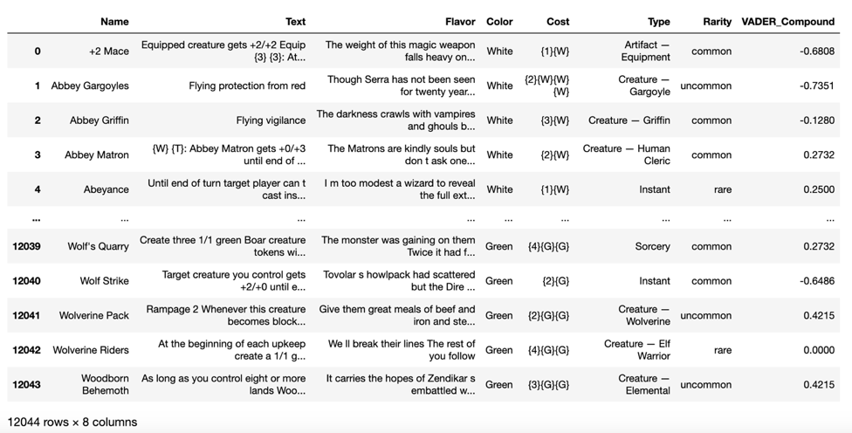

First, the mean, median, maximum, and minimum scores were computed from the entire set of cards and the results are shown in Figure 140. The results show that the flavor texts of the MtG cards are extremely balanced with the mean score within the neutral range and median score at a perfect neutral. The cards are not all written neutrally however, as the maximum value is an almost perfect positive rating, and the minimum value is an almost perfect negative rating. By selecting the rows of the data frame with the maximum and minimum scores, the most positive and negative cards can be identified.

**Figure 140) Summary Values of Sentiment Scores of All Cards**

|  |  |
| --- | --- |
| Mean | -0.01437 |
| Median | 0.0 |
| Maximum | 0.963 |
| Minimum | -0.9792 |

The most positive and most negative cards are shown in Figure 141. The most positive card, Growth Spurt, comes from the Unglued expansion which was released in 1998. This was a set that was intended for use outside of the normal MtG game and was made just for fun. The flavor text of this card reads like a dating profile and features the words “love”, “loving”, and “friendly” which contributed to its almost entirely positive sentiment score. The most negative card, Restless Bones, comes from the Guildpact expansion released in 2006. This card features reanimated skeletons and the flavor text references mourning, shrouding, and burying the dead, but then having to kill the dead again when they come back to life. These words certainly contributed to it having such a strong negative sentiment rating.

**Figure 141) The Most Positive and Negative Cards According to VADER Sentiment Scores**

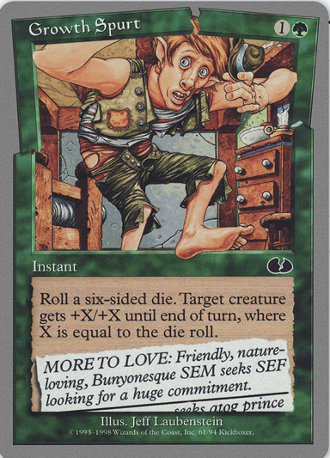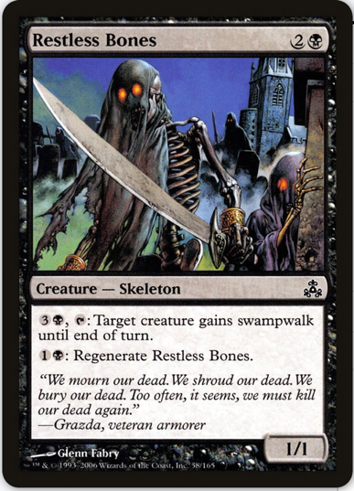

*Source: Scryfall.com card search*

Next, the results were aggregated according to color and the mean, median, maximum, and minimum scores were produced for each. These scores were saved as a data frame which is displayed in Figure 142. This data frame reveals that all the colors except for black have an overall neutral sentiment. The sentiment for the black cards is also weakly negative and still quite close to the neutral score range of -0.05 to 0.05. Also, within each color, there is at least one card that has a very strong positive sentiment and at least one card that has a very strong negative sentiment. The black cards may have lower scores than the other colors because of the theme of the characters having power over death. Even if the greater context was positive, the presence of those death related words would cause the text to get a lower VADER compound sentiment score.

**Figure 142) VADER Sentiment Summary Scores for Each Color**

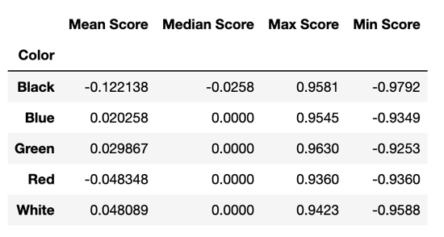

Figure 143 shows the most positive and negative black cards according to the sentiment scores. The most positive card, Dinosaur Hunter, contains some positive words like “best” and “easy”, but when all the words are taken in context is not that positive, since this card is about getting revenge. As previously discussed, however, the most negative card, Restless Bones, truly does have a negative sentiment. These results show a weakness in using the VADER sentiment analysis. Since it calculates the scores on a word-by-word basis, there are times when the score is not representative of the sentiment within the full context of the statements.

**Figure 143) Most Positive and Negative Black Cards**

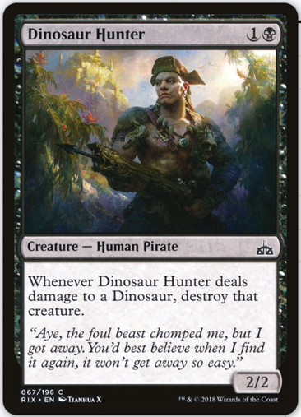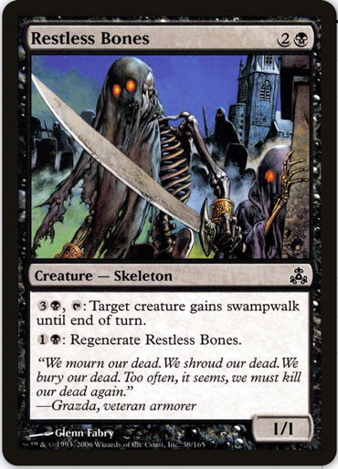

*Source: Scryfall.com card search*

Figure 144 shows the most positive and negative blue cards according to the sentiment scores. The most positive card, Soaring Show-Off, does contain a positive sentiment when taken in context. This card is about happy spectators supporting a competitor. The most negative card, Ioreth of the Healing House, certainly has a negative sentiment. The flavor text contains the words “crying”, “shouting”, “murdering”, and “sick”, and describes the difficulty of trying to heal people under adverse conditions.

**Figure 144) Most Positive and Negative Blue Cards**

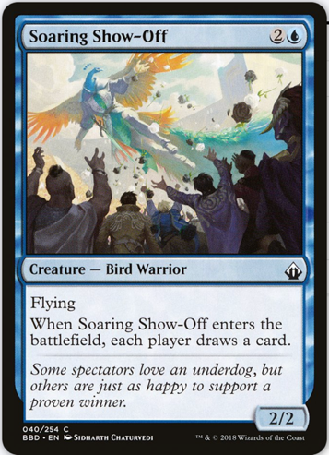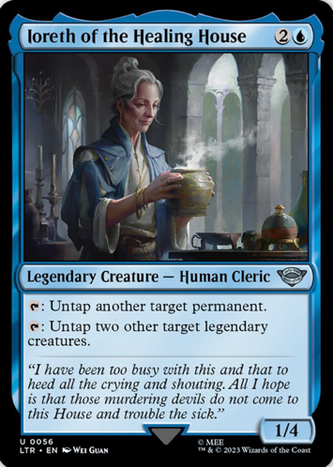

*Source: Scryfall.com card search*

Figure 145 shows the most positive and negative green cards according to the sentiment scores. As previously discussed, the most positive card, Growth Spurt, does have a positive sentiment in context. The most negative card, Silhana Ledgewalker, does not exactly contain a negative sentiment. This flavor text likely achieved a strong negative score because of the words “mockery”, “envy”, and “harm”, but the VADER sentiment intensity analyzer is not picking up on the negation. Although, this character is made fun of, it is because of how jealous people are of their skills. So, the Silhana Ledgewalker is actually thought of in a positive manner.

**Figure 145) Most Positive and Negative Green Cards**

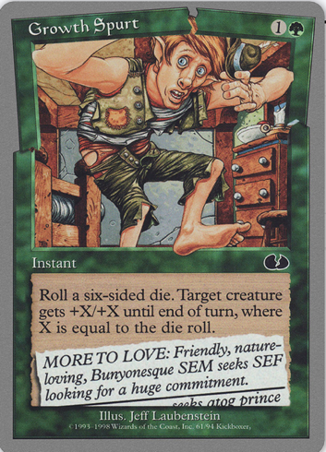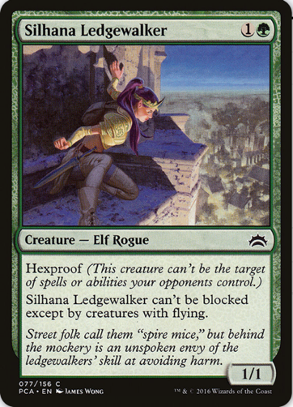

*Source: Scryfall.com card search*

Figure 146 shows the most positive and negative red cards according to the sentiment scores. The most positive card, Goblin Bookie, has a fun flavor text with a positive sentiment in context. It contains the words “loved” and “laugh” is about a goblin having fun gambling. The most negative card, Lambholt Harrier, certainly has a negative sentiment in context. This flavor text contains words like “howling”, “terrorize”, “fear”, and “worst”. This text describes a creature that wears down its prey before moving in to strike.

**Figure 146) Most Positive and Negative Red Cards**

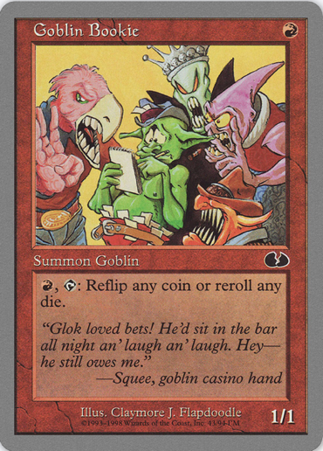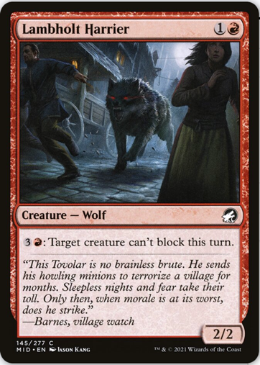

*Source: Scryfall.com card search*

Figure 147 shows the most positive and negative white cards according to the sentiment scores. The most positive card, Liu Bei, Lord of Shu, does contain positive words, but seems to actually be more neutral in sentiment. Words like “virtue”, “truly”, and “devotion” may have caused this flavor text to be assigned a strong positive score, but the text is just a quote that is describing Liu Bei’s thoughts. Since this is just relaying information, it does not expressly contain a positive sentiment. The most negative card, Angel of Renewal, is also misclassified. Once again, the VADER sentiment analysis is not picking up on the function of negation in written language. Within the flavor text are the phrases “no more fear” and “no more death”, which while containing the negative sentiment words “fear” and “death”, actually expresses a positive sentiment.

**Figure 147) Most Positive and Negative White Cards**

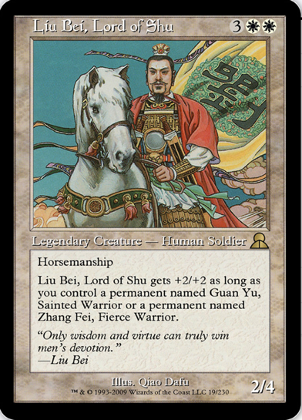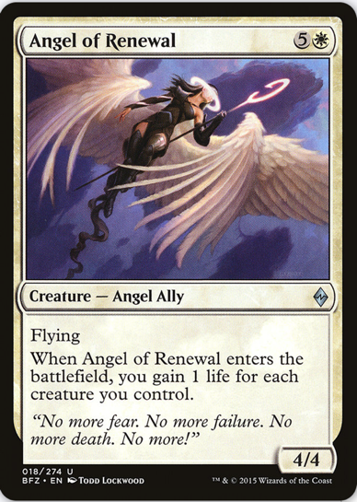

*Source: Scryfall.com card search*

While the results of this sentiment analysis highlight some weaknesses of the VADER sentiment intensity analyzer, the majority of the most positive and most negative cards were classified in the same way that a reader would likely interpret them. Since VADER scores the texts on a word-by-word basis, it sometimes misses out on important context or negated phrases.

The overall neutrality of the aggregated results could imply that that the designers have carefully crafted each of the colors to contain both positive and negative elements such as featuring heroes and villains alike. This balance ensures that no color can be seen by the player community as being the good one or the bad one. If a player was drawn to only play decks featuring good characters, they would be severely limited if all the heroes were only printed in a single color. For some players, the role-playing aspect is just as important as the utility of the deck, so being limited to that single color could cause them to lose interest in the game over time as the experience would feel stagnant.

As new cards are designed, the developers should continue to include positive and negative cards in all the colors. This way the MtG universe continues to feel realistic to players, as all the regions would have their good and bad characters, creatures, storylines, and powers.

## **Conclusion**

Magic: The Gathering has grown and maintained an immense popularity over the last thirty years. Starting as just an idea in a single person’s head, MtG has evolved into a global phenomenon. It is not only the most popular and successful trading card game, but has been generating over one billion dollars in revenue each year for parent company Hasbro. This level of success means there is more potential for MtG than ever before. In 2023, the MtG professional tour’s world championship event is slated to award one million dollars to those who compete. Also this year, Wizards of the Coast is releasing four full expansions as well as six supplemental mini-sets and is already working on cards that will be released throughout the next three years at similar rates. Many of these expansions are the results of Wizards of the Coast now partnering with other popular fantasy franchises, known as MtG Universes Beyond. In 2023, two Lord of the Rings themed expansions were released (Fig. 148), in 2024, there will be expansions based on the video game series Fallout and Assassin’s Creed, and in 2025, there will be a full release set based around the Final Fantasy series. All this means the developers are working harder than ever before and have a lot of pressure to get things right. Now, not only does MtG’s reputation hinge on its releases, but the reputations of other globally famous franchises do as well. Also, to properly adapt other franchises into MtG requires a lot of creativity. The developers must figure out how to fit popular characters and other well-known storylines into the five color mana system of MtG in ways that will satisfy fans of MtG, fans of the other franchises, and fans of both.

**Figure 148) Two Cards from the LoTR Expansion**

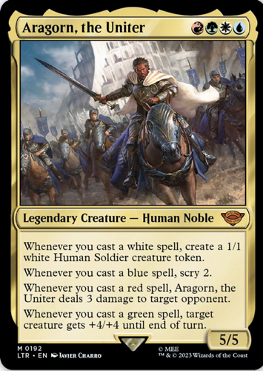 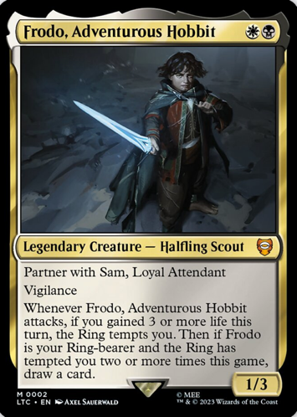

*Source: Scryfall.com card search*

These expansions bring with them new rules, mechanics, and multicolor combinations. Using the two cards in Figure 148 as an example, Aragorn, the Uniter is a four color multicolor card requiring one red, one green, one white, and one blue mana to play. It also has four different powers depending on which colors of cards you play after it has been summoned. This is a very difficult card to build a deck around and to summon into play, so its abilities must be extremely powerful to balance that out. Also, the Frodo, Adventurous Hobbit card brings new rules and gameplay elements to MtG. The “Partner” keyword introduces mechanics that are specific to two cards when they are played together in the same deck. This card also relates established MtG mechanics to choosing a creature that is “your Ring-bearer” and additional bonuses that come with that. Just these two cards alone highlight a lot of the challenges of constantly expanding an already massive game. How do the developers design a four color card that players will actually want to use, instead of them just feeling like it’s too much effort to bother with? How do the developers decide that powers unrelated to MtG should require specific colors of mana to use? And how do these cards fit in with the other “regular” MtG cards that can be played in the same game formats?

Thankfully, that thirty-year history of MtG cards is able to help the developers better understand their own game to assist them in overcoming these monumental tasks. The most appropriate color of a card can be determined just based on the words used in the card text that describes what abilities that card has. The implications of certain keywords will feel natural to MtG veterans such as red cards having “haste” and green cards having “trample”, but as the game continues to expand, the developers cannot just keep printing cards that do those same things. Dreaming up new ways to use each color of mana alongside their established abilities must take up a lot of the developers’ brainpower with tens of thousands of cards already having been written. Having software that can detect what color a card should be based on its text lightens the burdens on the developers and can make them more secure in their decisions. When a developer is writing a new card, they may already have a color in mind, but in an attempt to make an interesting card players will want to use, they could decide to push the boundaries of what that color of mana should be able to do. Being able to check against all the previous MtG cards to see if this new card can fit within that color, or if it would work better as a different color or even a multicolor card, can bring a lot of peace of mind and accelerate the development process. While developers could easily argue with one another, it is more difficult to argue with the tens of thousands of cards preceding them.

Another important aspect of the game design process is the flavor text. This italicized text printed on many of the cards helps to make them come to life. Instead of just being a piece of thin cardboard, the card and the character showcased in its art now have a backstory and a place in the MtG world. This helps players connect with the characters and can influence what color of deck and type of creature that a player wants to use. The flavor text on Darksteel Plate (Fig. 149) is a quote from a warrior who is showing their determination in battle. This makes this card come alive. It is no longer just some pieces of armor, but the armor that a particular character used to help them survive.

**Figure 149) Darksteel Plate MtG Card**

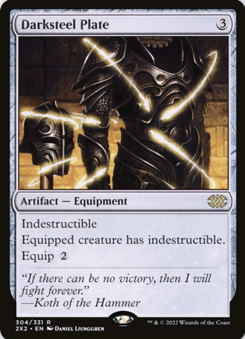

*Source: Scryfall.com card search*

Being able to identify prevalent topics within the flavor texts can help the developers continue to build a cohesive fantasy world with storylines that have good continuity over many years. If cards of every color are just randomly given backstories just for the fun of it, the stories in MtG would quickly become a jumbled mess and players would no longer connect with the cards. Understanding the stories about goblins helps write better red flavor text, while knowing about the different types of magic and the wizards that utilize them helps write better blue flavor text. Certain stories are so prominent that they should span the flavor texts of multiple colors of card, so it is important to identify those as well. These could be the basis for multiple expansions, like with the Weatherlight saga which ran from 1997 to 2001.

Another important aspect of the flavor text design principles present in MtG is how the developers have found a way to balance the good and evil within each color. When looking at the positivity and negativity found in the flavor texts across the game, all the colors are quite close to neutral. This does not mean that all the cards are written objectively, however, as there are cards within each color that are very positive and very negative. The red cards feature a goblin that is having fun gambling, while also featuring a malicious creature hunting its prey. Each color is filled with similar examples of heroes and villains, hope and despair, and war and shelter. By not making a single color stand out as “the bad one”, players who enjoy imagining themselves on either side of the morality spectrum can find interesting cards in all the colors. This gives players more enjoyment and freedom while collecting cards and building decks. It also makes the MtG universe more believable, as there would naturally be good and bad present in any society.

By leveraging the great amount of information contained in the text of the previous MtG cards, game developers are able to confidently continue building on Garfield’s original vision for the game. Better understanding the history of the cards included in the game, how they relate to each color of mana, and how they fit in with the stories and lore of the universe can help inspire the developers to create new and exciting ideas. Some of these ideas could be quite risky and lead to polarizing opinions among players, so by having a system that can evaluate how well new cards fit into the existing game there is more security in trying something new. This will be important than ever as MtG is now creating a multiverse comprised of fantasy franchises from across the globe. These new expansions will bring in even more players than ever before, and fusing those new card ideas more intricately into the already established designs will help ease those players into what can be an intimidating and overwhelming experience and retain them as consumers and competitors for years to come.